ANNOUNCEMENTS
September 17, 2017
“Enter reverently, meditate quietly, worship devoutly, leave gratefully, serve Christ faithfully.”

WELCOME TO ALL OUR VISITORS! If you are interested in knowing more about St. Peter’s, please see an usher or one of the greeters who stand with the clergy after the service.

TODAY AT ST. PETER'S
8:30 am Holy Eucharist Rite I
10:00 am Holy Eucharist Rite II (Nursery available)
Children’s Chapel
11:15 am Christian Formation-Children, Youth & Adults
5:00 pm Eucharist in Spanish in the Chapel
7:00 pm Canterbury C3 7pm at St. Peter’s

LOOKING AHEAD:
Monday/18 Living Compass 1pm
Tuesday/Sept 19 Chair Yoga 11am
Healing Service 12:15pm
Canterbury Club at Berry College 5pm
Wednesday/Sept 20 Celtic Service 5:30
Parish Dinner 5:45
Living Compass 6pm
EYC – Game Night
Thursday/Sept 21 Centering Prayer 6:30 pm
Friday/Sept 22 Community Kitchen Volunteer

LAY MINISTERS: (8:30) Reader/Prayers/Chalice Bearer – Mark Jester; (10:00) 1st Lesson –Janet Byington; 2nd Lesson – David Harvey; Prayers – Bob Steinbruegge; Chalice Bearers –Curt Yarbrough, Buster Wright, Bill Byington, Allien McNair.

CANDLES are given by Tom Kent to the Glory of God and in loving memory of Anna Marie Kent.

ALTAR ARRANGEMENTS are given by M.J. Chisholm to the Glory of God and in memory of Robert D. Chisholm and Dr. C.J. Wyatt.

CHAPEL ARRANGEMENTS are given by Peggy Nash to the Glory of God and in memory of her parents, Bobbie and Bob Williams.

INTERCESSORY PRAYER LIST Charlie Rutledge, Mike & Meg Alexander, Neil Sanders, Fran Bagley, Barbara Wyatt, Gene Braddock, Jack Edgens, June Dellis, Margaret Ingram, Terry Morris, Gene Lanier, Troy Beacham, Harrison Rozier, Jean Flanigen, Bill Guche, Randy Warley, Jamie Hughes, Kathy Rood, Bryant Steele and those who provide them care.

To add a name to the PRAYER LIST or MILITARY LIST, contact the church office. The prayer list will be refreshed the 1st Sunday of every month.

SYMPATHY OF THE PARISH is extended to John and Lea Duncan on the death of John’s younger brother, Philip Duncan who died on September 11, 2017.

Happy Birthday to those celebrating birthdays (September 17 – September 23) Brent Daly, Beverly Woodward, Forrest Schrum, Hollye Smith, Nicolas Burgess, Randy Warley, Lizzie Bressette, Stephen Laseter, Adam Tarrant, Rob Page, Wade Carpenter, Maia Santamaria, George Johnson, Ladonna Woods, Anne McConnell, Stephen Taylor and Madeline Baggett.

THE MARKET – Today is the last day, stop by Daniel Hall after church for antiques and collectibles. Beginning at 3pm TODAY members of St. Peter’s are invited to buy things at a very special price. Unsold items will be sold on a “make an offer” basis. Some items are excluded from special pricing. The Lord loves a cheerful giver.
PICTORIAL DIRECTORY
NOW TAKING APPOINTMENTS!
Register ON LINE via church website or call 877.896.9667 extension 360 or the church office.
October 13th, 14th, 15th
Friday 1pm to 8pm ~ Sat. 10am to 6pm ~ Sunday 12:30pm to 6pm
Each family will receive a FREE 8x10 photo as well as a bound directory.
Stop by TODAY after 10am service outside Chapel to sign up.

MISSION AND OUTREACH – September Donations Please consider donating to the Music & Memory Program at Mercy Care to help senior patients who suffer from Alzheimer’s disease and other forms of dementia. They are asking for
- Inexpensive headphones
- Craft items including markers, beads, & elastic for making jewelry
- iTune gift cards will also be appreciated because music is a wonderful therapy for seniors suffering from memory loss. Donation bins are located in the hallway between Daniel Hall and the Rhodes-Wyatt room. Thanks for taking time to care about this vulnerable group of adults.
Bring your donations to Daniel Hall and place in the bins located in the hallway. Thank you for taking time to care about this vulnerable group of adults.
COMMUNITY KITCHEN
Friday – September 22
Tuesday – September 26
Contact Andye Moss, agm614@aol.com or 706.506.4695

WEDNESDAY DINNER
9/20/2017 Baked Potato Bar with Salad and Cookies
Reservations Required, call or email the church office by noon on Tuesday with your reservation.

OKTOBERFEST
Planning has begun and you are needed as a VOLUNTEER for: decorators, servers (no cooking), help with games, bartenders, and costume judges. Call/email the office to volunteer today!
Octoberfest scheduled for October 25th.

CHRISTIAN FORMATION FOR ADULTS
Join us after the 10am service

ADULT FORUM – will meet in the sanctuary TODAY and is engaged in an intensive study of the Book of Common Prayer. This week Father John will discuss The Liturgies.

CANTERBURY CLUB CORNER

Chefs needed Fall Semester has started and Canterbury Club is back in action! For the past years, parish members have graciously ministered to our students by providing a home cooked meal for our meetings. If you feel called to prepare dinner for a dozen or so students, please contact me soon! Meetings on Tuesdays at 5 pm. Rebecca 706-331-6363

Calendar collection Canterbury Club wants to put your extra 2018 calendars to good use. As part of our service to the community, we are collecting calendars for families served by DFACS. Collection boxes located in Daniel Hall & the church office through December 31st.

LIVING COMPASS – The Tuesday class for the BOOK STUDY has been cancelled. Participants have moved to classes offered on Monday and Wednesday during this study series.

CHILDREN’S CORNER!

Fifteenth Sunday after Pentecost

Nursery/Toddler care is available and is located on the 2nd floor of the Education Building for the 10am service, beginning at 9:45am.

Children’s Chapel is available for children ages pre-k through 3rd grade during the 10am worship service on the 2nd floor of the Education Building.

If your younger children are staying with you in the pew during service, we are delighted to have the whole family joining us in worship.

Little ones are always welcome.

For Busy Little Hands in Church: We provide scriptural coloring sheets, crayons, and a children’s guide to the Eucharist, in the back of the church to help children in understanding our scripture readings and our corporate worship.

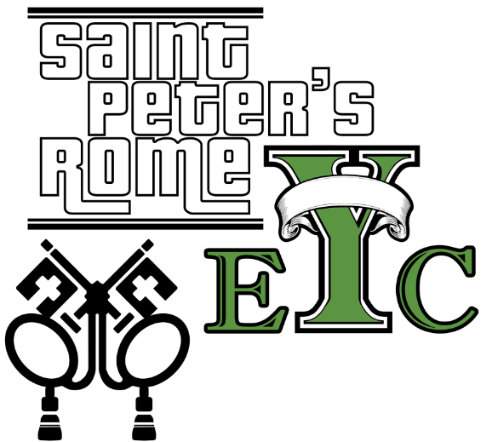
Wednesday, Sept.20th Bible Games & SNACKS!
Drop off at the church at 6:30, pick up at 8:15
EYC is open to all students grades 6 to 12.
Friends are Welcome!

UPCOMING EYC EVENTS:
Wednesday Sept 27th Nerf Hide & Seek at the church
Saturday Sept 30th SIX FLAGS leave 9am from church, reservations required. Call or email church.

GET CONNECTED!
Want to see what our small ones and youth are up to at St. Peter’s? Check out our Facebook pages: St. Peter’s Sunday School &
St. Peter’s Rome EYC.

Church Office: Phone - 706.291.9111 Fax - 706.232.5007 Email: elizabeth@stpetersrome.org
Office Hours: Monday – Thursday 8am to 4pm and Friday 9am to 12 noon
St Peter’s Episcopal Church/St Peter’s Sunday School/St. Peter’s Rome EYC
St. Peter’s Junior Choir
www.stpetersrome.org

