ANNOUNCEMENTS
September 10, 2017
“Enter reverently, meditate quietly, worship devoutly, leave gratefully, serve Christ faithfully.”

WELCOME TO ALL OUR VISITORS! If you are interested in knowing more about St. Peter’s, please see an usher or one of the greeters who stand with the clergy after the service.

TODAY AT ST. PETER'S
8:30 am Holy Eucharist Rite I
9:00 am Breakfast
10:00 am Holy Eucharist Rite II (Nursery available)
Children’s Chapel
11:15 am Christian Formation-Children, Youth & Adults
5:00 pm Eucharist in Spanish in the Chapel

LOOKING AHEAD:
Tuesday/Sept 12 Chair Yoga 11am
Healing Service 12:15pm
Canterbury Club at Berry College 5pm
Wednesday/Sept 13 Celtic Service 5:30
EYC – Schroeder’s Night
Thursday/Sept 14 Centering Prayer 6:30 pm

LAY MINISTERS: (8:30) Reader/Prayers/Chalice Bearer – Tricia Richards; (10:00) 1st Lesson –Len Woodward; 2nd Lesson – Keith Summerlin; Prayers – Bryant Steele; Chalice Bearers –Tom Dasher, Bryan Johnson, Annette Morris, Delores Nowell.

CANDLES are given by Tom Kent to the Glory of God and in loving memory of Anna Marie Kent.

ALTAR ARRANGEMENTS are given to the Glory of God and in thanksgiving for Mary & Curt Yarbrough by their children.

CHAPEL ARRANGEMENTS are given by Marsha Welch and her family to the Glory of God and in memory of Gary Welch and Frances and Mark Johnson.

INTERCESSORY PRAYER LIST Charlie Rutledge, Mike & Meg Alexander, Neil Sanders, Fran Bagley, Barbara Wyatt, Gene Braddock, Jack Edgens, June Dellis, Margaret Ingram, Terry Morris, Gene Lanier, Troy Beacham, Harrison Rozier, Jean Flanigan, Bill Guche nd those who provide them care.

To add a name to the PRAYER LIST or MILITARY LIST, contact the church office. The prayer list will be refreshed the 1st Sunday of every month.

Happy Birthday to those celebrating birthdays (September 10 – September 16) Julia Livesay, Madge Tate, Zibby White, Charles Steeves, John Gilliam, Mary Niedrach, Jackson Hodges, Stephen Moseley, Shelley Parris, Beverly Birdyshaw, John Herring and Clay Hardaker.

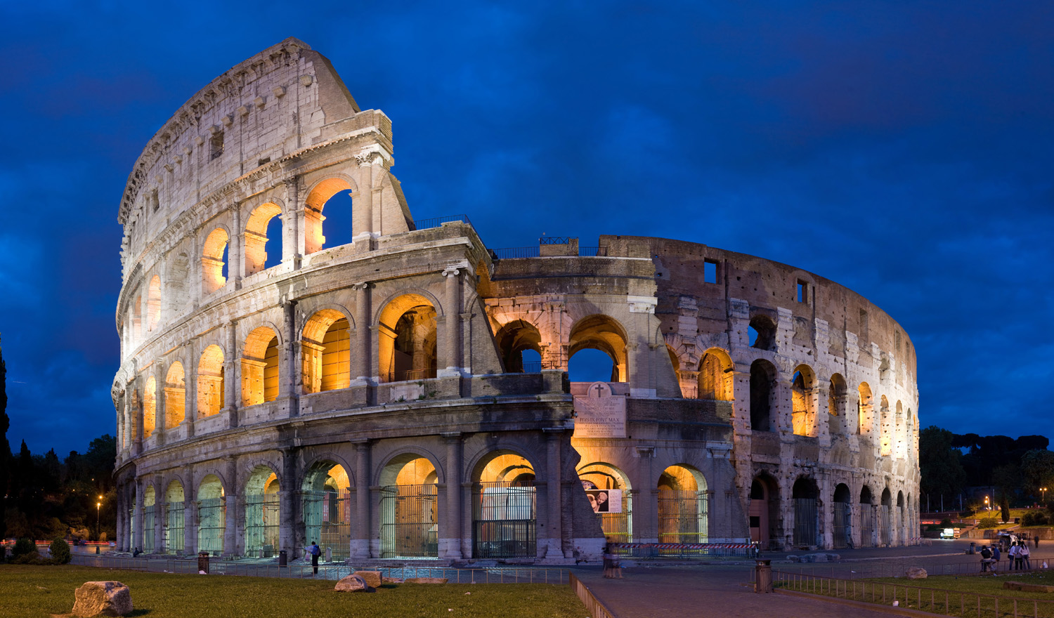
ANTIQUES & COLLECTIBLES MARKET - Sept 16th & 17th

The Market is NEXT WEEKNED, from noon to 3:30pm. Deliver your donated items to Daniel Hall today through Wednesday September 13th. Collection time today is noon-3pm all other days 10am-3pm. Please place donations on the stage.

Proceeds from The Market will fund the Youths Pilgrimage in 2018 to Italy.

LIVING COMPASS CONGREGATIONAL WELLNESS

Sessions start THIS week.
3 sessions are offered: Monday at 1pm, Tuesday at 9:30am & Wednesday at 6pm. Contact Beth Hughes 706.506.9636 or D’Ann Downey 706.236.3444 to sign up.
Books available TODAY see Beth Hughes in Choir Room after 8:30 service or in Daniel Hall after 10am service.

PICTORIAL DIRECTORY
NOW TAKING APPOINTMENTS!
Register ON LINE or by phone, see bulletin insert for details.
October 12th, 13th, 14th, 15th
Thursday & Friday 1pm to 8pm
Sat. 10am to 6pm
Sunday 12:30pm to 6pm
Each family will receive a FREE 8x10 photo as well as a bound directory.
Green Screen Technology allows you to focus on creating beautiful portraits by capturing the very best expressions and poses, then YOU choose from a variety of backgrounds!

WEDNESDAY DINNER is taking this week OFF due to The Market. Pizza is available for participants of the Children’s Choir ONLY. Baked Potato Bar will be back on 9/20/2017.

OKTOBERFEST – Just around the corner…Planning has begun & volunteers are needed for: decorators, servers (no cooking), help with games, bartenders, and costume judges. Call/email the office to volunteer today!
Octoberfest scheduled for October 25th.

CHRISTIAN FORMATION FOR ADULTS
Join us after the 10am service

ADULT FORUM – meets in Daniel Hall and is engaged in an intensive study of the Book of Common Prayer. This week Tom Dasher will discuss the importance of language in the Book of Common Prayer.

YOU are needed just 1 Wednesday night a month!
NO cooking, NO clean up, just serving dinner for an hour beginning at 5:30pm. Choose to serve when it fits YOUR schedule as little as once a month! Call or e-mail the church office to lend a hand.
Your St. Peter’s parish family thanks you!!

CANTERBURY CLUB CORNER

Chefs needed Fall Semester has started and Canterbury Club is back in action! For the past years, parish members have graciously ministered to our students by providing a home cooked meal for our meetings. If you feel called to prepare dinner for a dozen or so students, please contact me soon! Meetings on Tuesdays at 5 pm. Rebecca 706-331-6363

Calendar collection Canterbury Club wants to put your extra 2018 calendars to good use. As part of our service to the community, we are collecting calendars for families served by DFACS. Collection boxes located in Daniel Hall & the church office through December 31st.

MISSION AND OUTREACH – National Grandparents Day is celebrated in September; a great month to focus on residents at Mercy CareYou can help by donating supplies for the Music & Memory program. Appropriate items to donate are: iTune gift cards (Walmart, Target, Walgreens); inexpensive headphones, & craft items including markers, beads & elastic for making jewelry. Please bring your donations to Daniel Hall and place in the bins located in the hallway. This is a wonderful way to honor our senior citizens.
CHILDREN’S CORNER!

Fourteenth Sunday after Pentecost

Nursery/Toddler care is available and is located on the 2nd floor of the Education Building for the 10am service, beginning at 9:45am.

Children’s Chapel is available for children ages pre-k through 3rd grade during the 10am worship service on the 2nd floor of the Education Building.

If your younger children are staying with you in the pew during service, we are delighted to have the whole family joining us in worship.

Little ones are always welcome.

For Busy Little Hands in Church: We provide scriptural coloring sheets, crayons, and a children’s guide to the Eucharist, in the back of the church to help children in understanding our scripture readings and our corporate worship.

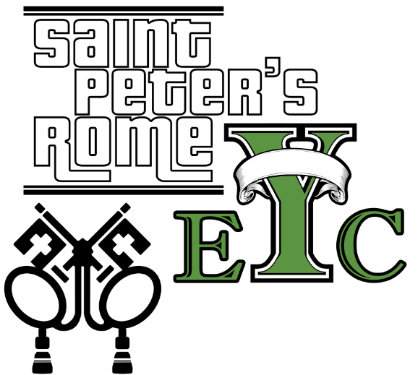
Wednesday, Sept.13th Schroeder’s Night
Bring $ to offset the cost of food.
Drop off at the church at 6:30, pick up at 8:15
EYC is open to all students grades 6 to 12.
Friends are Welcome!

UPCOMING EYC EVENTS:
Wednesday Sept 20th Bible Games at the church
Wednesday Sept 27th Nerf Hide and Seek at the church
Saturday Sept 30th SIX FLAGS leave 9am from church, reservations required.

GET CONNECTED!
Want to see what our small ones and youth are up to at St. Peter’s? Check out our Facebook pages: St. Peter’s Sunday School &
St. Peter’s Rome EYC.

Church Office: Phone - 706.291.9111 Fax - 706.232.5007 Email: elizabeth@stpetersrome.org
Office Hours: Monday – Thursday 8am to 4pm and Friday 9am to 12 noon
St Peter’s Episcopal Church/St Peter’s Sunday School/St. Peter’s Rome EYC
St. Peter’s Junior Choir
www.stpetersrome.org

