ANNOUNCEMENTS
August 27, 2017
“Enter reverently, meditate quietly, worship devoutly, leave gratefully, serve Christ faithfully.”

WELCOME TO ALL OUR VISITORS! If you are interested in knowing more about St. Peter’s, please see an usher or one of the greeters who stand with the clergy after the service.

TODAY AT ST. PETER'S
8:30 am Holy Eucharist Rite I
9:00 am Breakfast
10:00 am Holy Eucharist Rite II (Nursery available)
Children’s Chapel
11:15 am Christian Formation-Children, Youth & Adults
5:00 pm Eucharist in Spanish in the Chapel

LOOKING AHEAD:
Tuesday/August 29 Chair Yoga 11am
Healing Service 12:15pm
Canterbury Club at Berry College 5pm
Stewardship Committee 5:30pm
Wednesday/August 30 Celtic Service 5:30pm
Parish Dinner 5:45pm
EYC – Bowling 6:30pm

LAY MINISTERS: (8:30) Reader/Prayers/Chalice Bearer – Tricia Richards; (10:00) 1st Lesson –Delores Nowell; 2nd Lesson – Chris Noth; Prayers – Tom Dasher; Chalice Bearers –Sunny Knauss, Brian Hampton, Annette Morris, Keith Summerlin.

ALTAR ARRANGEMENTS are given by the George Anderson family to the Glory of God and in memory of Jean, George R. Everett and William Peter Anderson.

CHAPEL ARRANGEMENTS are given by Jerry and Sharon Norman to the Glory of God and in loving memory of their daughter, Christy Jones Hernandez Nixon.

INTERCESSORY PRAYER LIST Charlie Rutledge, Mike Alexander, Neil Sanders, Fran Bagley, Barbara Wyatt, Carol Summer, Bill Schoepski, Joe McNair, David Chester, Gene Braddock, Troy Beacham, Barnes Coble, Jack Edgens, Harrison Rozier, June Dellis, Gene Lanier, Alicia Segars, Mary Patton, Meg Alexander, Nell and Jim Hamrick, Wayne Johnston, Ann Caroll Followill and those who provide them care.

To add a name to the PRAYER LIST or MILITARY LIST, contact the church office. The prayer list will be refreshed the 1st Sunday of every month.

CONGRATULATIONS OF THE PARISH
- Extended to Patricia Richards on the birth of twin grandchildren on July 20, 2017, Barnes Hammond Coble and Elizabeth Hiatt Coble. Parents are Elizabeth and Elliott Coble of New Bern, North Carolina.
- Extended to Sara and Ben McElrath on the birth of their son, Harris West McElrath on August 16th. He is also the grandson of Linda and Ed Hine.

Happy Birthday to those celebrating birthdays (August 27 – September 2) Patricia Harvey, Cynthia Murphy Burnes, Teague Williams, Jerry Norman, Todd Horton, Larry Osborn, Greer Sims, Elise O’Neill, Jason Stephens, Kathy Steinbruegge, Wanda Cantrell, Bryan Johnson.

CHRISTIAN FORMATION FOR ADULTS
Join us after the 10am service

ADULT FORUM – meets in Daniel Hall and is engaged in an intensive study of the Book of Common Prayer. This week Nat Massey will discuss The Daily Office.
WIRED WORD – meets in the Rhodes Wyatt Room and will link the latest headlines to appropriate scripture.

ANTIQUES & COLLECTIBLES MARKET
The Market is only three weeks away, September 16th from 8am to 5pm and September 17th from noon to 3:30pm. For those of you who plan to donate items, please bring them to Daniel Hall on Sunday September 10th through Wednesday September 13th. Collection time on Sunday noon-3pm all other days 10am-3pm. Please place donations on the stage.

Proceeds from The Market sales will fund the Youths Pilgrimage in 2018 to Italy.

LOOKING for a QUICK & EASY way to SERVE?
Servers are needed for our Wednesday Night Family Suppers. NO cooking, NO cleaning, just serving dinner for an hour on Wednesdays beginning at 5:45pm. Choose to serve as often as you want…it’s up to you! Just call or e-mail the church office to choose your date(s). It’s that simple!! Your St. Peter’s parish family thanks you!!
CHEFS NEEDED
Fall Semester has started and Canterbury Club is back in action! For the past years, parish members have graciously ministered to our students by providing a home cooked meal for our meetings. If you feel called to prepare dinner for a dozen or so students, please contact me soon!
Meetings on Tuesdays at 5 pm beginning August 29th. =) Rebecca 706-331-6363

BIBLE STUDY – Mark your calendars to join the weekly Thursday Bible Study group as they begin their study of LUKE on September 7, 2017. The group meets at 10am in the Rhodes Wyatt room.

MISSION AND OUTREACH for August is a simple request for donations of pens, pencils, and/or individually wrapped children sized toothbrushes to support Brighter Birthdays. Volunteers put together birthday bags filled with party supplies, treats, crafts, toys, and basic living essentials.

LIVING COMPASS CONGREGATIONAL WELLNESS

Sessions start the week of September 11th.
Three sessions are offered: Monday at 1pm, Tuesday at 9:30am & Wednesday at 6pm. Contact Beth Hughes 706.506.9636 or D’Ann Downey 706.236.3444 to sign up.

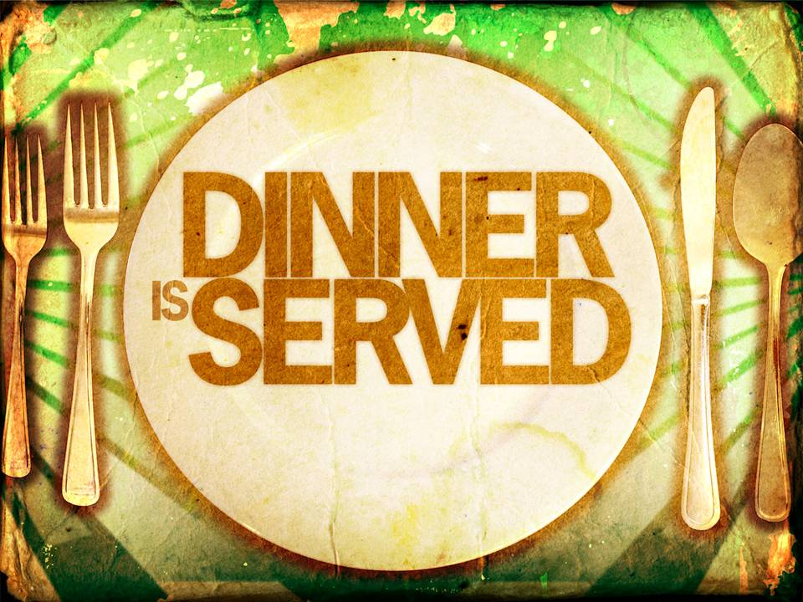
WEDNESDAY PARISH DINNER
Lasagna/Salad/Garlic Bread served at 5:45pm.
RESERVATIONS REQUIRED by noon on Tuesday, call/email the church office.
Food is prepared on the number of reservations.
Extra meals will NOT be available.

LETTERS TO THE ROMANS - Deadline for the September newsletter is August 28th. Please email the church office with your news.

STEWARDSHIP Committee Meeting - Tuesday 5:30p.m. in the Rhodes Wyatt Room.
CHILDREN’S CORNER!

Twelfth Sunday after Pentecost

Nursery/Toddler care is available
and is located on the 2nd floor of the Education Building for the 10am service, beginning at 9:45am.

Children’s Chapel is available for children ages pre-k through 3rd grade during the 10am worship service on the 2nd floor of the Education Building.
If your younger children are staying with you in the pew during service, we are delighted to have the whole family joining us in worship.

Little ones are always welcome.

For Busy Little Hands in Church: We provide scriptural coloring sheets, crayons, and a children’s guide to the Eucharist, in the back of the church to help children in understanding our scripture readings and our corporate worship.

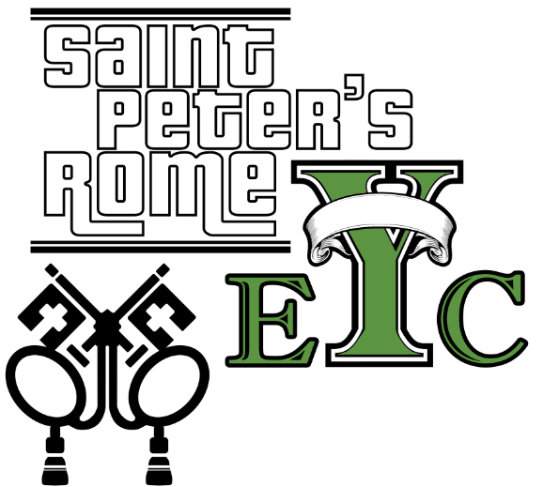
Wednesday, AUGUST 30th BOWLING!
6:30 at Floyd Bowling & Amusement on Riverbend, p/u at 8:15 at the same location.

EYC is open to all students grades 6th to 12th.
Friends are Welcome!

GET CONNECTED!
Want to see what our small ones and youth are up to at St. Peter’s? Check out or Facebook pages St. Peter’s Sunday School and
St. Peter’s Rome EYC.

Church Office: Phone - 706.291.9111 Fax - 706.232.5007 Email: elizabeth@stpetersrome.org
Office Hours: Monday – Thursday 8am to 4pm and Friday 9am to 12 noon
St Peter’s Episcopal Church/St Peter’s Sunday School/St. Peter’s Rome EYC
www.stpetersrome.org

