ANNOUNCEMENTS
May 7, 2017
Rite 13 Sunday
“Enter reverently, meditate quietly, worship devoutly, leave gratefully, serve Christ faithfully.”

WELCOME TO ALL OUR VISITORS! If you are interested in knowing more about St. Peter’s, please see an usher or one of the greeters who stand with the clergy after the service.

TODAY AT ST. PETER'S
8:30 am Holy Eucharist Rite I
9:00 am Breakfast
VBS Registration Daniel Hall
10:00 am Holy Eucharist Rite II (Nursery available)
Children’s Chapel
VBS Registration Daniel Hall
11:15 am Wired Word, Adult Forum
5:00 pm Eucharist in Spanish in the Chapel

LOOKING AHEAD:

Monday/May 8 Living Compass – Aging Well 1:30pm
Tuesday/May 9 Chair Yoga 11am
Healing 12:15pm
Wednesday/May 10 Celtic 5:30pm
Adult & Children’s Choir rehearsal
Parish Dinner – Final dinner before summer break
EYC – Schroeder’s Night
Living Compass – Spiritual Wellness 6pm
Thursday/May 11 Bible Study 10 a.m. – Hebrews
Centering Prayer 6:30pm

LAY MINISTERS: (8:30) Reader/Prayers/Chalice Bearer – Dawn Hampton; (10:00) 1st Lesson – David Harvey; 2nd Lesson – Janet Byington; Prayers – Bryant Steele; Chalice Bearers – Bill Byington, Bryant Steele, Jody McDaniel, Keith Summerlin.

ALTAR CANDLES are given by Nancy and Jack Knight to the Glory of God and in memory of Jean McRae and Pistol Knight.

ALTAR ARRANGEMENTS are given by Cissy Rogers to the Glory of God and in memory of Jack Rogers.

CHAPEL ARRANGEMENTS are given by Anne and Christopher Kerr and Rebekah McGinnis to the Glory of God and in loving memory of Frederick Kerr.

INTERCESSORY PRAYER LIST Charlie Rutledge, Mike Alexander, Neil Sanders, Jason Breese, Billy Muzekari, Bill Guche, Carol Summer, Tracy Kight, Barbara Wyatt, Murphy Grace Mosley and those who provide them care.

To add a name to the PRAYER LIST, contact the church office. The prayer list will be refreshed the 1st Sunday of every month.

Happy Birthday to those celebrating birthdays (May 7 – May 13) Timothy King, Allison Ledbetter, Peyton Albertson, Bruce Hunter, Charlie Bell, Jim Keaten, Elaine Smith, Emily Thurmond, Sebastian White, Mary Louise Lever, and Janet Flippen.

CONGRATULATIONS of the parish extended to Pat York and Annie Shields for their marriage at Glendale Chapel on Saturday April 29,2017.

ADULT FORUM - Join us in Daniel Hall immediately after the 10:00 a.m. Eucharist for our continuing study of The Story. This week we will discuss The End of Time (Chapter 31). Next week we will meet for a final wrap-up and feedback session for The Story during Adult Forum.

WIRED WORD meets in the Rhodes-Wyatt room immediately following the 10:00 a.m. Eucharist. Each week we take an item from the news or current events and provide an opportunity to reflect on how our faith responds to or interacts with the concern through a mixture of scriptures, big questions, and discussion. “Wired Word” encourages participants to consider how following Jesus puts them in touch with the wider world.

MISSON & OUTREACH for MAY

May is National Foster Care Month. Floyd County has over 400 children in the Foster Care system. Children and youth enter foster care because they have been abused, neglected, or abandoned by their parents or guardians. All of these children have experienced loss and some form of trauma. CASA (County Appointed Special Advocate) volunteers are appointed by judges to advocate for the best interests of these children. CASA volunteers need coloring books, crayons, and markers to use for these children during initial intake meetings. If you would like to help a child in the foster care system, please bring your donation to Daniel Hall in May.

VBS VOLUNTEERS Adult and youth volunteers are needed. To volunteer call or text Erika Wilson at 334-328-8807 Or come to the VBS kickoff on May 7th and see the different volunteer opportunities and sign up.

WEDNESDAY PARISH DINNER – The FINAL Parish dinner before we break for Summer. Call the church office by noon on Wednesday to make your reservation OR change a standing reservation. Join the group!
VBS REGISTRATION TODAY in Daniel Hall BEFORE & AFTER the 10am service, register your little ones for the most fun VBS ever!

ST. PETER’S Vacation Bible School
June 5th-9th, 2017
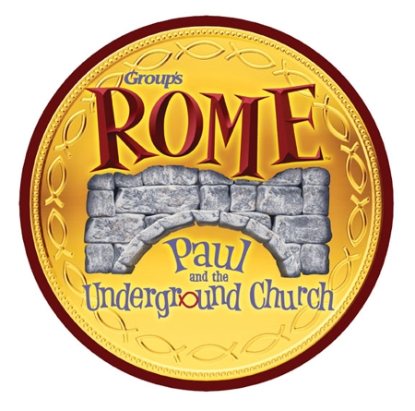
Get ready for Rome: Paul and the Underground Church!
This is a VBS adventure in which kids from Rome, GA can travel back in time to experience the devotion and excitement of being a part of God’s underground church during the time of Roman rule. We’ll follow along with St. Paul as he does God’s work to strengthen God’s people and put in place the foundation of the church we know today! Join us in Rome: Paul and the Underground Church!

VOLUNTEER OPPORTUNTIES:

HABITAT FOR HUMANITY – Volunteer to assist in the ReStore to sort, clean and price donations given to Habitat to fund the building of houses. Call 706.378.0030 OR email torri@habitatcoosevalley.org to volunteer.

COMMUNITY KITCHEN MAY 19th Contact Andye Moss agm614@aol.com to volunteer & help in the community kitchen. St. Peters date for JUNE is 6/23/2017.

RESTORATION ROME Mondays & Fridays 9am to noon. Volunteers are needed to sort and process donations at the Clothes Closet at Restoration Rome. Please call Jeanne Mathews at 706-676-1039 if you can help.

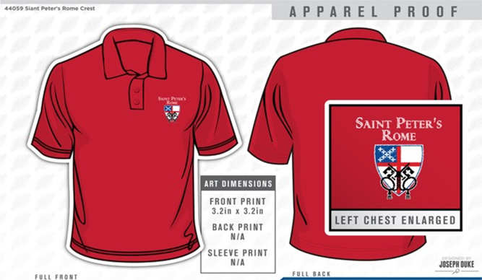

GET YOUR RED ON!
Limited sizes available, up to 3XL. Call the Church office NOW to get your very own St. Peter’s Logo Polo shirt. ONLY $25 and it will come in handy next month for St. Peter’s Day!

Church Office: Phone - 706.291.9111 Fax - 706.232.5007 Email: elizabeth@stpetersrome.org
Office Hours: Monday – Thursday 8am to 4pm and Friday 9am to 12 noon
Website: stpetersrome.org Facebook: St Peter’s Episcopal Church
CHILDREN’S CORNER!
Fourth Sunday of Easter

Children’s Chapel is available through May 14 and Nursery/Toddler care is available as well. Both of these are on the 2nd floor of the Education Building during the 10am service.

If your younger children are staying with you in the pew during service, we are delighted to have the whole family joining us in worship. Little ones are always welcome.

For Busy Little Hands in Church: We provide scriptural coloring sheets, crayons, and a children’s guide to the Eucharist, in the back of the church to help children in understanding our scripture readings and our corporate worship.

Sunday School will resume in August.

~~~~~EYC EVENTS ~~~~~
EYC is open to 6th-12th graders, and all gap year students!

EYC – Wednesday It’s Schroeder’s Night. Bring $5 to offset costs. Parent drop off at 6:30 and p/u at 8:15 at the church.

Save the Date! EYC SCHOOL’S OUT! lock-in May 26-27! Dave and Buster’s, here we come!!! Bring $10.00 for transportation and food, (we eat pizza here before we leave), PLUS whatever extra you plan to spend on games and other stuff at D & B’s. Parent drop off at 6pm on Friday, p/u at 9:00am on Saturday.

Parents/guardians of children in 5th grade or younger, please continue to escort your children to and from class, and sign them in and out. This is part of how we keep our little lambs safe.

