

**ANNOUNCEMENTS**

**May 28, 2017**

***“Enter reverently, meditate quietly, worship devoutly, leave gratefully, serve Christ faithfully.”***

**WELCOME TO ALL OUR VISITORS!**  If you are interested in knowing more about St. Peter’s, please see an usher or one of the greeters who stand with the clergy after the service.

**TODAY AT ST. PETER'S**

8:30 am Holy Eucharist Rite I

9:00 am Breakfast

10:00 am Holy Eucharist Rite II (Nursery available)

Reception following service

11:15 am Wired Word

5:00 pm Eucharist in Spanish in the Chapel

**LOOKING AHEAD:**

Monday/May 29 **Living Compass – Aging Well 1:30pm**

Tuesday/May 30 **Chair Yoga 11am**

**Healing 12:15pm**

Wednesday/May 31 **Celtic 5:30pm**

**Living Compass – Spiritual Wellness 6pm**

Thursday/June 1 **Centering Prayer 6:30pm**

**LAY MINISTERS:** (8:30) Reader/Prayers/Chalice Bearer – Dawn Hampton; (10:00) 1st Lesson –D’Ann Downey; 2nd Lesson – Norman Fletcher; Prayers – Buster Wright; Chalice Bearers – Sunny Knauss, Heidi Cole, Delores Nowell, Andye Moss.

**ALTAR ARRANGEMENTS** are given by the Parke Avery Family to the Glory of God and in honor of The Reverend Janice Bracken Wright and in memory of departed loved ones.

**CHAPEL ARRANGEMENTS** are given by Tom Dasher and Jim Noon to the Glory of God and in thanksgiving for St. Peter’s, our families and especially for the ministry of Janice Bracken Wright.

**INTERCESSORY PRAYER LIST** Charlie Rutledge, Mike Alexander, Neil Sanders, Jason Breese, Bill Guche, Carol Summer, Tracy Kight, Barbara Wyatt, David Chester, Jerome, John Garner, Kevin Skelly, Adlai Wood, Alicia Segars, Tom Dasher, Pat Kelley, Fran Bagley, Louisa Johnston, Faye Spicer, Dawn Hampton, Jack Edgens and those who provide them care.

*To add a name to the PRAYER LIST, contact the church office. The prayer list will be refreshed the 1st Sunday of every month.*

**SYMPATHY OF THE PARISH** is extended to Annette Morris on the death of her brother, Billy Muzekari on 5/18/2017 and to the friends and family of Dr. Peter A. Lawler who died on 5/21/2017.

**Happy Birthday** to those celebrating birthdays (May 29 – June 3) Bobby Mixon, Leigh Ann Anderson, Mary Yarbrough, Melissa Tarrant, Vick Sims, Jane Swanson, Molly Rutledge, Steve Protz, Spencer Carroll, Anthea Evans, Richard Dunwoody, Tressa Baggett, Tammy Barron, Lindsay Wyatt, Ethan Sumner, Larry Mooseberg, Cathy Varidel, Ladre Floyd, Curt Yarbrough, Gayle Keith, Patty Hunter, Helen Lansing, Jennifer Shipp, and Katherine Kuckhoff.

**WIRED WORD** meets in the Rhodes-Wyatt room immediately following the 10:00 a.m. Eucharist. Each week we take an item from the news or current events and provide an opportunity to reflect on how our faith responds to or interacts with the concern through a mixture of scriptures, big questions, and discussion. “Wired Word” encourages participants to consider how following Jesus puts them in touch with the wider world.

**FINAL WEEK for:**

**MISSON & OUTREACH for MAY**



**May is National Foster Care Month**. Floyd County has over 400 children in the Foster Care system. Children and youth enter foster care because they have been abused, neglected, or abandoned by their parents or guardians. All of these children have experienced loss and some form of trauma. CASA (County Appointed Special Advocate) volunteers are appointed by judges to advocate for the best interests of these children.

**CASA volunteers need coloring books, crayons, and markers** to use for these children during initial intake meetings. If you would like to help a child in the foster care system, please bring your donation to Daniel Hall in May.

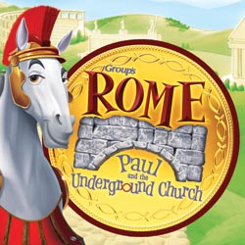

**ST. PETER’S VBS**

**Is Here!**

**June 5th-9th, 2017**

**9am to noon**

**Ages 4yrs to 5th grade, Nursery provided**

Get ready for Rome:

**Paul and the Underground Church!**

This is a VBS adventure in which kids from Rome, GA can travel back in time to experience the devotion and excitement of being a part of God’s underground church during the time of Roman rule. We’ll follow along with St. Paul as he does God’s work to strengthen God’s people and put in place the foundation of the church we know today! Join us in Rome: Paul and the Underground Church!

We’ll follow along with St. Paul as he does God’s work to strengthen God’s people and put in place the foundation of the church we know today!

**Registration forms in Daniel Hall on table & VBS Bulletin Board**.

AND, speaking of Vacation Bible School…

We are getting ready to step back in time to ancient Rome and the early church…

**Join in the fun!**

We need your help with donations of decorating and snack items; a great way to be part of VBS if you are unable to join us for the week.

**DECORATIONS:**  anything that might be found in ancient Rome (burlap, rugs, terra cotta pottery, fake greenery, columns, fake fruit, etc.) PLEASE PLACE DECORATIONS IN BINS IN DANIEL HALL BY **SAT 6/3** & LABEL WITH NAME IF YOU WANT IT BACK!

**SNACKS:**  We can use donations of goldfish, raisins, hummus, loose apples, cheese cubes.  PLEASE PLACE SNACKS IN THE KITCHEN BY MONDAY 6/5.

If you want to join the actual fun, call/text Erika Wilson at 334.328.8807 or email to [encwilson@yahoo.com](mailto:encwilson@yahoo.com)!

OR you can use the link below to access the sign-up genius for VBS snacks or decorations help:

<http://www.signupgenius.com/go/10c094caca72aa1f58-stpeters>

**CHILDREN’S CORNER!**

**Seventh Sunday of Easter**

**Nursery/Toddler care is available all through the summer.** Nursery is located on the 2nd floor of the Education Building during the 10am service, beginning at 9:45am.

**If your younger children are staying with you in the pew during service, we are delighted to have the whole family joining us in worship.**

**Little ones are always welcome**.

**For Busy Little Hands in Church:** We provide scriptural coloring sheets, crayons, and a children’s guide to the Eucharist, in the back of the church to help children in understanding our scripture readings and our corporate worship.

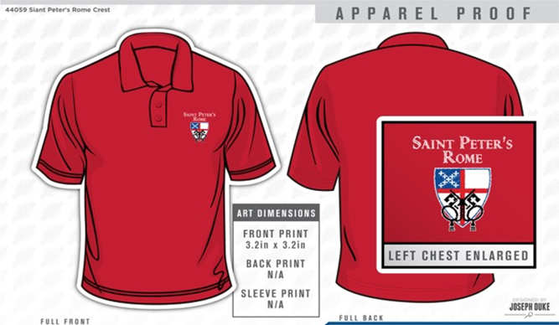

**GET YOUR RED ON!**

Limited sizes available, youth to 3XL. Call the Church office NOW to get your very own St. Peter’s Logo Polo shirt. ONLY $25 and it will come in handy next month for St. Peter’s Day!



**PARISHIONER Contact Information –** Do you need updated contact information for your fellow parishioners? Contact the church office and we will **email** a current directory to you.



**MEMORIAL DAY –** The church office will be Closed Monday, 5/27/2018 in observance of Memorial Day.

**Church Office**: Phone - 706.291.9111 Fax - 706.232.5007 Email: [elizabeth@stpetersrome.org](mailto:elizabeth@stpetersrome.org)

**Office Hours:** Monday – Thursday 8am to 4pm and Friday 9am to 12 noon

**Website**: stpetersrome.org  **Facebook**: St Peter’s Episcopal Church