ANNOUNCEMENTS
May 14, 2017
“Enter reverently, meditate quietly, worship devoutly, leave gratefully, serve Christ faithfully.”

WELCOME TO ALL OUR VISITORS! If you are interested in knowing more about St. Peter’s, please see an usher or one of the greeters who stand with the clergy after the service.

TODAY AT ST. PETER'S
8:30 am Holy Eucharist Rite I
9:00 am Breakfast
10:00 am Holy Eucharist Rite II (Nursery available)
Children’s Chapel
11:15 am Wired Word
5:00 pm Eucharist in Spanish in the Chapel

LOOKING AHEAD:

Monday/May 15 Living Compass – Aging Well 1:30pm
Tuesday/May 16 Chair Yoga 11am
Healing 12:15pm
Wednesday/May 17 Celtic 5:30pm
Adult Choir rehearsal
EYC – Swift and Finch
Living Compass – Spiritual Wellness 6pm
Thursday/May 18 Centering Prayer 6:30pm
Friday/May 19 Community Kitchen Volunteers

LAY MINISTERS: (8:30) Reader/Prayers/Chalice Bearer – Mark Jester; (10:00) 1st Lesson –Brian Hampton ; 2nd Lesson –Brian Hampton ; Prayers – Bob Berry; Chalice Bearers – Brian Hampton, Annette Morris, Bryan Johnson, Rebecca Roberts.

ALTAR ARRANGEMENTS are given by Gordon Lee Hight to the Glory of God and in memory of Sue Ellenburg Hight, Charles and Alberta Hight, Irene Matthews Hight and Gordon and Irene Hight.

CHAPEL ARRANGEMENTS are given by Andye Moss and the Drew Moss family to the Glory of God and in loving memory of Lucille Grubb, Lois Moss and Sally Hitchcock.
INTERCESSORY PRAYER LIST Charlie Rutledge, Mike Alexander, Neil Sanders, Jason Breese, Billy Muzekari, Bill Guche, Carol Summer, Tracy Kight, Barbara Wyatt, David Chester, Jerome, John Garner, Kevin Skelly, Adlai Wood, Alicia Segars, Tom Dasher, Pat Kelley, Fran Bagley, Louisa Johnston and those who provide them care.

To add a name to the PRAYER LIST, contact the church office. The prayer list will be refreshed the 1st Sunday of every month.

Happy Birthday to those celebrating birthdays (May 14 – May 20) Janice, Jim, Janice, Dannette, Sarah Anne, Dean, Patrick, Blair, Connie, Juli, Robert and Remy.

CONGRATULATIONS to Grandmother Anne Kerr and Uncle Chris Kerr on the birth of Georgia Anne Scott born May 8th to Rebekah Kerr McGinnis and Spencer McGinnis in Cambridge MA.

WIRED WORD meets in the Rhodes-Wyatt room immediately following the 10:00 a.m. Eucharist. Each week we take an item from the news or current events and provide an opportunity to reflect on how our faith responds to or interacts with the concern through a mixture of scriptures, big questions, and discussion. “Wired Word” encourages participants to consider how following Jesus puts them in touch with the wider world.

MISSON & OUTREACH for MAY

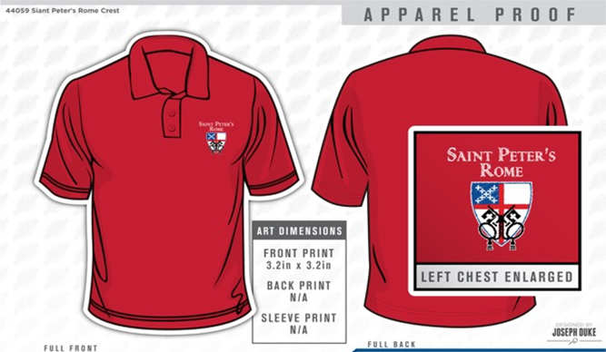
May is National Foster Care Month. Floyd County has over 400 children in the Foster Care system. Children and youth enter foster care because they have been abused, neglected, or abandoned by their parents or guardians. All of these children have experienced loss and some form of trauma. CASA (County Appointed Special Advocate) volunteers are appointed by judges to advocate for the best interests of these children. CASA volunteers need coloring books, crayons, and markers to use for these children during initial intake meetings. If you would like to help a child in the foster care system, please bring your donation to Daniel Hall in May.

GET YOUR RED ON!
Limited sizes available, youth to 3XL. Call the Church office NOW to get your very own St. Peter’s Logo Polo shirt. ONLY $25 and it will come in handy next month for St. Peter’s Day!

RECEPTION FOR JANICE BRACKEN WRIGHT – Join the Parish as they gather to celebrate and honor Janice and her 34 year commitment to St. Peter’s. Reception on May 28th immediately following the 10 service. If you wish to contribute towards a gift to be made in her honor please mail your check to the church office.

VOLUNTEER OPPORTUNTIES:

HABITAT FOR HUMANITY – Volunteer to assist in the ReStore to sort, clean and price donations given to Habitat to fund the building of houses. Call 706.378.0030 OR email torri@habitatcoosevalley.org to volunteer.

COMMUNITY KITCHEN MAY 19th Contact Andye Moss agm614@aol.com to volunteer & help in the community kitchen. St. Peters date for JUNE is 6/23/2017.

CONGRATULATIONS to our graduates from your church family at St. Peter’s! We love you, we are so proud of you!

High School Graduates:
Alex Hodges - Rome High School on May 20th, he will attend Berry College
Heidi Cole - Rome High School on May 20th, she will attend North Georgia College
Christina Kinder - Darlington School on May 13th, she will attend Mercer University

College Graduates:
Jason Roberson – Virginia Theological Seminary
Alexandra Rachel Carlton – University of Georgia
Stephen Wyatt – Berry College
Lindsay Wilson Wyatt – Reinhardt College
Nicci Corley – Berry College
Christina Gray Hubbard – Duke University
James Andrew Scott McDaniel – Birmingham Southern College
May God’s grace always be with you!

ST. PETER’S Vacation Bible School
June 5th-9th, 2017
9am to noon
Ages 4yrs to 5th grade, Nursery provided

Get ready for Rome:
Paul and the Underground Church!

We’ll follow along with St. Paul as he does God’s work to strengthen God’s people and put in place the foundation of the church we know today!

Registration forms in Daniel Hall on table & on the VBS Bulletin Board.

VBS VOLUNTEERS Adult and youth volunteers are needed. To volunteer call or text Erika Wilson at 334-328-8807.

Church Office: Phone - 706.291.9111 Fax - 706.232.5007 Email: elizabeth@stpetersrome.org
Office Hours: Monday – Thursday 8am to 4pm and Friday 9am to 12 noon
Website: stpetersrome.org Facebook: St Peter’s Episcopal Church

CHILDREN’S CORNER!
Fifth Sunday of Easter
Happy Mother’s Day!

Children’s Chapel is available through TODAY and Nursery/Toddler care is available as well. Both of these are on the 2nd floor of the Education Building during the 10am service.

If your younger children are staying with you in the pew during service, we are delighted to have the whole family joining us in worship. Little ones are always welcome.

For Busy Little Hands in Church: We provide scriptural coloring sheets, crayons, and a children’s guide to the Eucharist, in the back of the church to help children in understanding our scripture readings and our corporate worship.

~~~~~EYC EVENTS ~~~~~
EYC is open to 6th-12th graders, and all gap year students!

EYC – Wednesday Swift and Finch School’s Out (or almost) Celebration! Relax, drink (non-alcoholic) stuff, and release! Tests, papers, and projects are gone for another summer! Parent drop off is 6:30 and p/u is 8:15pm at church.
EYC SCHOOL’S OUT! lock-in May 26-27!
Dave and Buster’s, here we come!!! Bring $10.00 for transportation and food, (we eat pizza here before we leave), PLUS whatever extra you plan to spend on games and other stuff at D & B’s. Parent drop off at 6pm on Friday, p/u at 9:00am on Saturday.
RSVP with Mother Nikki+:
via email nikki@stpetersrome.org OR text 404.520.9798.

Parents/guardians of children in 5th grade or younger, please continue to escort your children to and from class, and sign them in and out. This is part of how we keep our little lambs safe.

