ANNOUNCEMENTS
September 24, 2017
“Enter reverently, meditate quietly, worship devoutly, leave gratefully, serve Christ faithfully.”

WELCOME TO ALL OUR VISITORS! If you are interested in knowing more about St. Peter’s, please see an usher or one of the greeters who stand with the clergy after the service.

TODAY AT ST. PETER'S
8:30 am Holy Eucharist Rite I
9:00 am Breakfast
10:00 am Holy Eucharist Rite II (Nursery available)
Children’s Chapel
11:15 am Christian Formation-Children, Youth & Adults
5:00 pm Eucharist in Spanish in the Chapel

LOOKING AHEAD:
Monday/25 Living Compass 1pm
Tuesday/Sept 26 Chair Yoga 11am
Healing Service 12:15pm
Canterbury Club at Berry College 5pm
Community Kitchen Volunteer
Wednesday/Sept 27 Celtic Service 5:30
Parish Dinner 5:45
Living Compass 6pm
EYC – Nerf Hide & Seek
Thursday/Sept 28 Centering Prayer 6:30 pm
Friday/Sept 29 Restoration Rome 9am

LAY MINISTERS: (8:30) Reader/Prayers/Chalice Bearer – Rachel Jones; (10:00) 1st Lesson –Andye Moss; 2nd Lesson – Bob Berry; Prayers – Wade Carpenter; Chalice Bearers –Aaron Summer, Brian Hampton, Tom Dasher, Sunny Knauss.

CANDLES are given by Tom Kent to the Glory of God and in loving memory of Anna Marie Kent.

ALTAR ARRANGEMENTS are given by the Stephen Patton family to the Glory of God and in memory of Mr. and Mrs. Ed Foster and other departed family members.

CHAPEL ARRANGEMENTS are given by Mrs. Bess Crawford to the Glory of God and in memory of Jerry Norwood Crawford and other departed loved ones.

INTERCESSORY PRAYER LIST Charlie Rutledge, Mike & Meg Alexander, Neil Sanders, Fran Bagley, Barbara Wyatt, Gene Braddock, Jack Edgens, June Dellis, Margaret Ingram, Terry Morris, Gene Lanier, Troy Beacham, Harrison Rozier, Jean Flanigen, Bill Guche, Randy Warley, Jamie Hughes, Kathy Rood, Bryant Steele, Alicia Segars, Mildred Edgeworth, Phillip Jenkins, Cathy Varidel, Julie Ousley, Kathleen Jacobs, Shelley Marlowe and those who provide them care.

To add a name to the PRAYER LIST or MILITARY LIST, contact the church office. The prayer list will be refreshed the 1st Sunday of every month.

SYMPATHY OF THE PARISH is extended to the family of Martha Anne Dunson who died at home on September 17, 2017. A private memorial garden service is being planned at St. Peter’s for immediate family.

Happy Birthday to those celebrating birthdays (September 24 – September 30) Jose Santamaria, Tracy Schroeder, Nat Massey, Susan Morgan, Virginia McChesney, Elizabeth McElrath, Emily White, Robert Branhan, Stephen Patton, Susan Cooper, Jennifer Cromer, Sarah Kilgore, and Emi Grace Wood.

JANE SWANSON funeral service will be held at St. Peter’s on September 30, 2017 at 1pm

PICTORIAL DIRECTORY
NOW TAKING APPOINTMENTS!
Register ON LINE via church website OR call 877.896.9667 extension 360 OR the church office.
October 13th and 14th and 16th
Friday & Monday 1pm to 8pm ~ Sat. 10am to 6pm
Monday the 16th IS NOW OPEN FOR APPOINTMENTS
Each family will receive a FREE 8x10 photo as well as a bound directory.
MISSION AND OUTREACH – September Donations Please consider donating to the Music & Memory Program at Mercy Care to help senior patients who suffer from Alzheimer’s disease and other forms of dementia.
They are asking for
- Inexpensive headphones
- Craft items including markers, beads, & elastic for making jewelry
- iTune gift cards will also be appreciated because music is a wonderful therapy for seniors suffering from memory loss. Donation bins are located in the hallway between Daniel Hall and the Rhodes-Wyatt room. Thanks for taking time to care about this vulnerable group of adults.
Bring your donations to Daniel Hall and place in the bins located in the hallway. Thank you for taking time to care about this vulnerable group of adults.
RESTORATION ROME – Clothes Closet
Volunteers are needed to help work on Friday mornings from 9-12. Please call Jeanne Mathews at 796-676-1039 to volunteer or if you have questions. They also accept gently used children's and teen clothing, new socks and underwear, toys and shoes.
COMMUNITY KITCHEN
Tuesday – September 26 8:30-10:15 OR 10:15-12:00
Contact Andye Moss, agm614@aol.com or 706.506.4695

WEDNESDAY DINNER 9/27/2017
Chicken Pot Pie/Salad/Dessert
Reservations Required, call or email the church office by noon on Tuesday with your reservation. Adults $5, Children $3, Maximum family expense $20

OKTOBERFEST
Planning has begun and you are needed as a VOLUNTEER for: decorators, servers (no cooking), help with games, bartenders, and costume judges. Call/email the office to volunteer today!
Octoberfest scheduled for October 25th.

CHRISTIAN FORMATION FOR ADULTS - meets in Daniel Hall and is engaged in an intensive study of the Book of Common Prayer. This week John Kirkland will discuss The Compile. Join us after the 10am service

CANTERBURY CLUB CORNER
Calendar collection Canterbury Club wants to put your extra 2018 calendars to good use. As part of our service to the community, we are collecting calendars for families served by DFACS. Collection boxes located in Daniel Hall & the church office through December 31st.

LETTERS TO THE ROMANS – submit all articles, pictures etc. to the church office by September 29th to be included in the October issue.
CHILDREN’S CORNER!

Sixteenth Sunday after Pentecost

Nursery/Toddler care is available and is located on the 2nd floor of the Education Building for the 10am service, beginning at 9:45am.

Children’s Chapel is available for children ages pre-k through 3rd grade during the 10am worship service on the 2nd floor of the Education Building.

If your younger children are staying with you in the pew during service, we are delighted to have the whole family joining us in worship.

Little ones are always welcome.

For Busy Little Hands in Church: We provide scriptural coloring sheets, crayons, and a children’s guide to the Eucharist, in the back of the church to help children in understanding our scripture readings and our corporate worship.

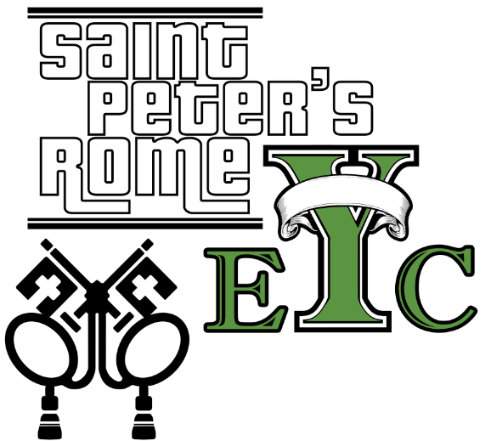
Wednesday, Sept.27th Nerf Hide & Seek & SNACKS!
Drop off at the church at 6:30, pick up at 8:15
EYC is open to all students grades 6 to 12.
Friends are Welcome!

UPCOMING EYC EVENTS:
Saturday Sept 30th SIX FLAGS leave 9am from church.
October 15th – YOUTH SUNDAY

NEXT SUNDAY 10/1/2017 No Children & Youth Sunday School.
GET CONNECTED!
Want to see what our small ones and youth are up to at St. Peter’s? Check out our Facebook pages: St. Peter’s Sunday School &
St. Peter’s Rome EYC.

Church Office: Phone - 706.291.9111 Fax - 706.232.5007 Email: elizabeth@stpetersrome.org
Office Hours: Monday – Thursday 8am to 4pm and Friday 9am to 12 noon
St Peter’s Episcopal Church/St Peter’s Sunday School/St. Peter’s Rome EYC
St. Peter’s Junior Choir
www.stpetersrome.org

