ANNOUNCEMENTS
August 13, 2017
“Enter reverently, meditate quietly, worship devoutly, leave gratefully, serve Christ faithfully.”

WELCOME TO ALL OUR VISITORS! If you are interested in knowing more about St. Peter’s, please see an usher or one of the greeters who stand with the clergy after the service.

TODAY AT ST. PETER'S
8:30 am Holy Eucharist Rite I
9:00 am Breakfast
10:00 am Holy Eucharist Rite II (Nursery available)
Children’s Chapel
11:15 am Christian Formation-Children, Youth & Adults
5:00 pm Eucharist in Spanish in the Chapel

LOOKING AHEAD:
Monday/August 14 Stewardship Meeting 5:30pm
Tuesday/August 15 Chair Yoga 11am
Healing Service 12:15pm
Vestry Meeting 5:30pm
Wednesday/August 16 Celtic Service 5:30pm
EYC – Schroeder’s Night 6:30pm
Thursday/August 17 Centering Prayer 6:30pm

LAY MINISTERS: (8:30) Reader/Prayers/Chalice Bearer – Rachel Jones; (10:00) 1st Lesson –Len Woodward; 2nd Lesson – Bob Steinbruegge; Prayers – Andye Moss; Chalice Bearers –Bryant Steele, Annette Morris, Delores Nowell, Brian Hampton.

CANDLES – are given by Mrs. Ladre Floyd to the Glory of God and in memory of departed loved ones.

ALTAR ARRANGEMENTS are given by Bob and Anthea Evans to the Glory of God and in memory of departed family members.

CHAPEL ARRANGEMENTS are given by Mr. and Mrs. Charles Hight, Jr. to the Glory of God and in loving memory of Irene Matthews Hight and Charles and Alberta Hight.

INTERCESSORY PRAYER LIST Charlie Rutledge, Mike Alexander, Neil Sanders, Fran Bagley, Barbara Wyatt, Carol Summer, Bill Schoepski, Joe McNair, David Chester, Gene Braddock, Troy Beacham, Barnes Coble, Jack Edgens, Harrison Rozier, June Dellis, Gene Lanier, Alicia Segars, Mary Patton and those who provide them care.

To add a name to the PRAYER LIST or MILITARY LIST, contact the church office. The prayer list will be refreshed the 1st Sunday of every month.

Happy Birthday to those celebrating birthdays (August 13 – August 19) Mike Lupo, Leland Scoggins, Christopher Kerr, Jeanne Mathews, Amy Massey, Ellice Teems, Campbell Ledbetter, Nia Rose, Amanda Kinder, Isabel Bonnyman, Dot Fletcher, and Brandon Carroll.

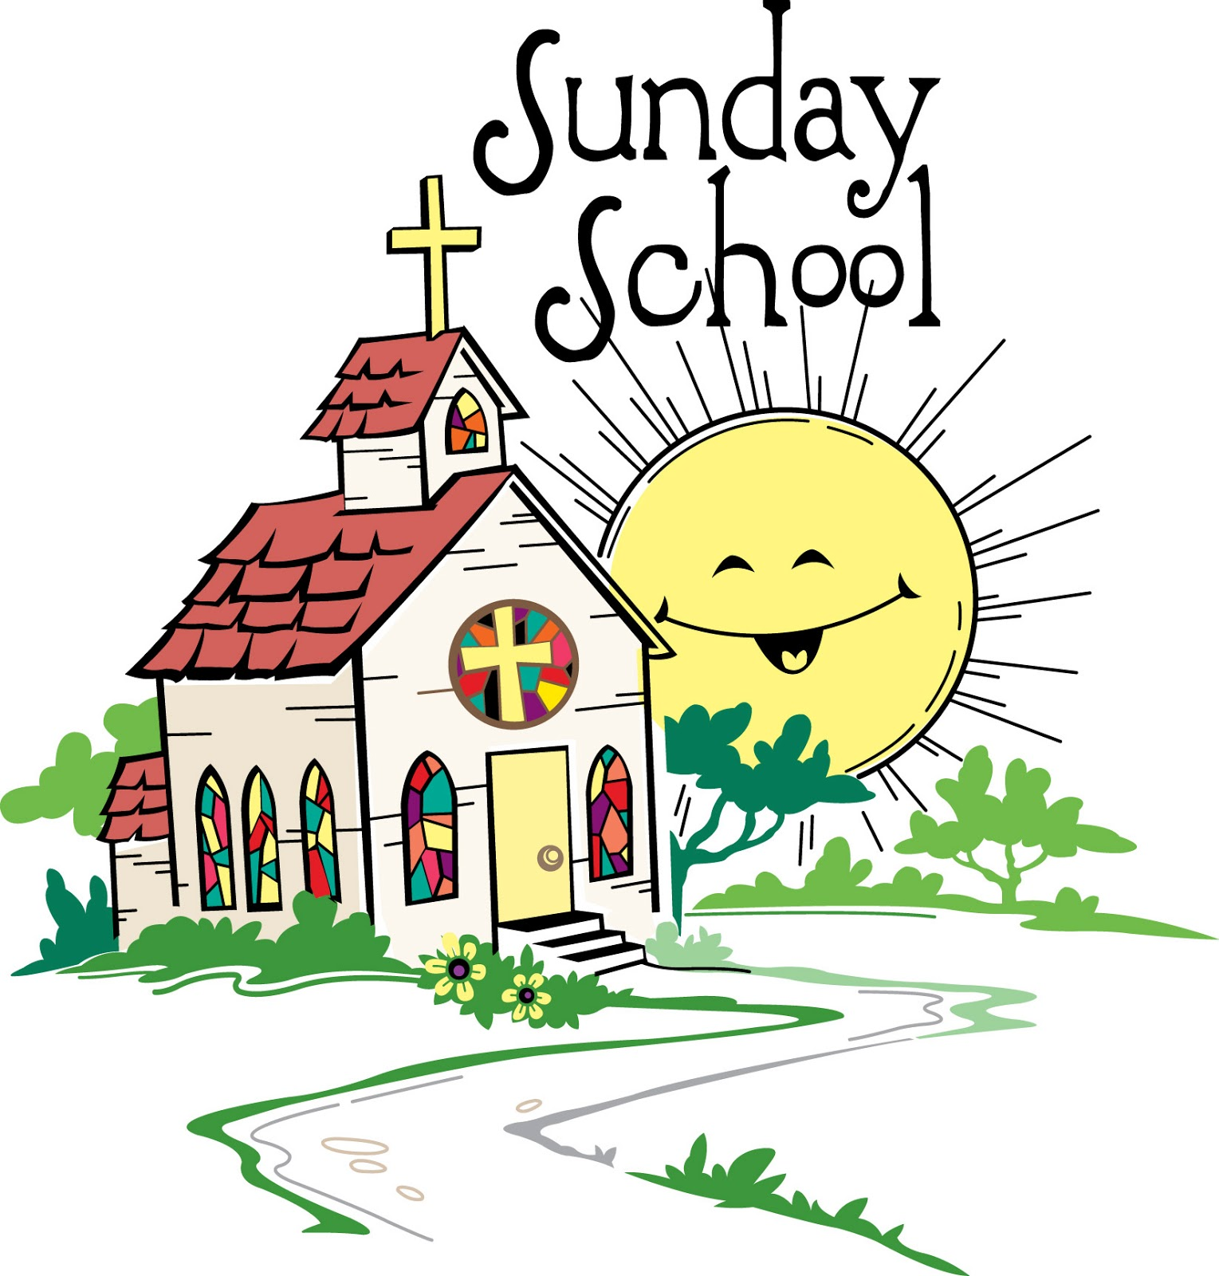
This Photo by Unknown Author is licensed under CC BY-NC-ND
Christian Formation IS BACK
Beginning TODAY Children, Teen and Adult Christian Formation begins at 11:15, following the 10am Service.

ADULT FORUM & WIRED WORD – Join us after the service in Daniel Hall for either Wired Word (Rhodes Wyatt Room) or Adult Forum (in Daniel Hall). This week Brain Hampton’s lecture is entitled “ #BCP.” Brian will discuss why we have those red books in the pews and the history behind their use in the Episcopal Church.

CONGRATULATIONS TO:
- Mai Mai Kelly & Cynthia Murphy Burnes- Graduation from EfM.
- Betsy Awsumb - Completion of 9 years of dedicated mentoring.
- Keith Summerlin – Certified EfM mentor.
Join with all EfM members in extending a hearty congratulations to these individuals for their work and dedication.

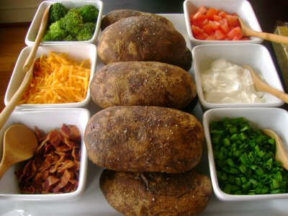
WEDNESDAY PARISH DINNER – Beginning August 23rd the weekly parish dinner will be served at 5:45pm. RESERVATIONS ARE REQUIRED by Tuesday at noon. Food is prepared solely on the number of RESERVATIONS received in the church office. Baked Potato Bar will be the meal on August 23rd.

COMMUNITY KITCHEN – AUGUST 25th, volunteer to help feed the hungry. Join other St. Peter’s Parishioners by contacting Andye Moss, agm614@aol.com. THANK YOU!
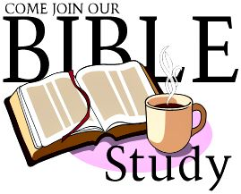

BIBLE STUDY – Mark your calendars to join the weekly Thursday Bible Study group as they begin their study of LUKE on September 7, 2017. The group meets at 10am in the Rhodes Wyatt room.

MISSION AND OUTREACH for August is a simple request for donations of pens, pencils, and/or individually wrapped toothbrushes to support Brighter Birthdays. Brighter Birthdays’ is dedicated to making birthdays brighter for underprivileged youth. Volunteers put together birthday bags filled with party supplies, treats, crafts, toys, and basic living essentials. School personnel identify children with upcoming birthdays and then distribute the Birthday Bags.
For more information about Brighter Birthdays visit their website at: https://www.brighterbirthdays.org or visit their Facebook page.

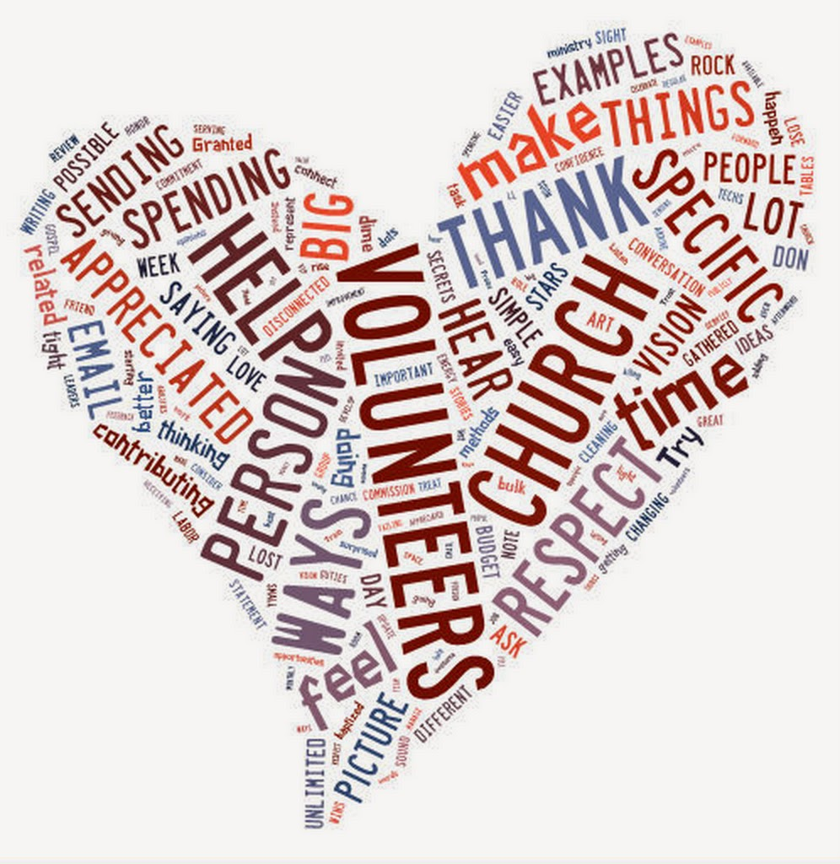
OFFICE VOLUNTEER – Have you ever considered being a volunteer to help in the church office? We could use your help. Morning shift from 9am to 12:30pm OR afternoons from 12:30 to 4pm. You choose which shift and which day of the week fits your schedule. Volunteer once a month or more it is up to you! Answer the phone, greet visitors, fold bulletins…it’s easy and fun! Call or email the office with questions or to volunteer. THANK YOU

Church Office: Phone - 706.291.9111 Fax - 706.232.5007 Email: elizabeth@stpetersrome.org
Office Hours: Monday – Thursday 8am to 4pm and Friday 9am to 12 noon
St Peter’s Episcopal Church or St Peter’s Sunday School or St. Peter’s Rome EYC
www.stpetersrome.org
CHILDREN’S CORNER!

Tenth Sunday after Pentecost
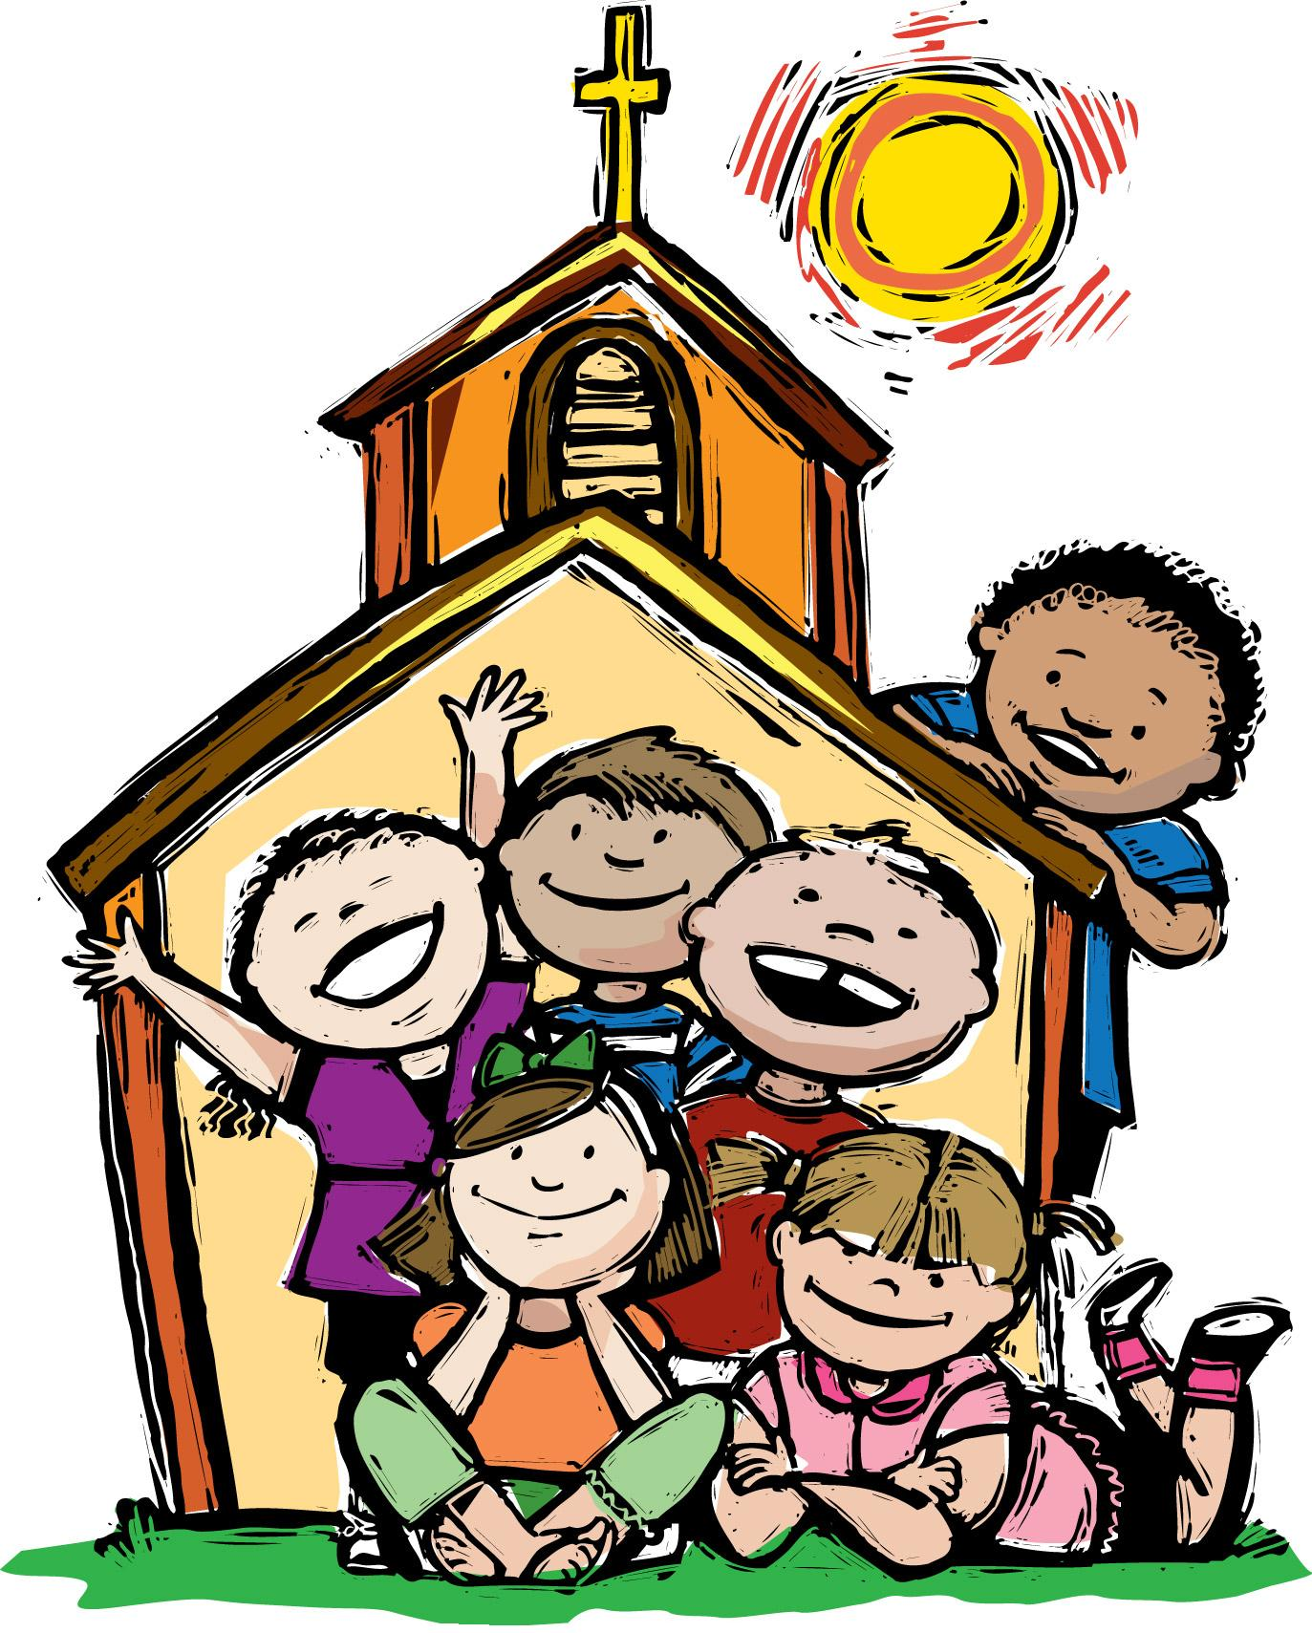

Nursery/Toddler care is available
and is located on the 2nd floor of the Education Building for the 10am service, beginning at 9:45am.

Children’s Chapel is available for children ages pre-k through 3rd grade during the 10am worship service on the 2nd floor of the Education Building.

If your younger children are staying with you in the pew during service, we are delighted to have the whole family joining us in worship.

Little ones are always welcome.

For Busy Little Hands in Church: We provide scriptural coloring sheets, crayons, and a children’s guide to the Eucharist, in the back of the church to help children in understanding our scripture readings and our corporate worship.
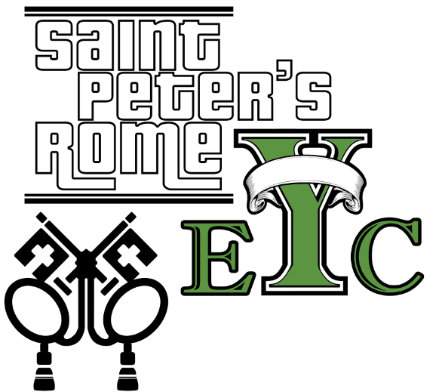

EYC IS BACK! SCHROEDERS NIGHT –
Wednesday, AUGUST 16th, $5
Meet at the church at 6:30pm, we will eat then back to church for Netflix and gabbing! BRING A FRIEND!
See you on Wednesday night.

CHILDRENS CHOIR – Come join the choir! Wednesday August 23, 2017 rehearsals will RESUME under the direction of Dagmar Carlton. See you at 6:15pm

