

**ANNOUNCEMENTS**

**May 6, 2018**

***“Enter reverently, meditate quietly, worship devoutly, leave gratefully, serve Christ faithfully.”***

**WELCOME TO ALL OUR VISITORS!**  If you are interested in knowing more about St. Peter’s, please see an usher or one of the greeters who stand with the clergy after the service.

**TODAY AT ST. PETER'S**

8:30 am Holy Eucharist Rite II

9:00 am Breakfast

10:00 am Holy Eucharist Rite II (Nursery available)

11:15 am Formation

11:15 am Conversation & Coffee

11:15 am Meet & Greet for Trey Clegg Singers

1:00 pm Holy Eucharist Rite II in Spanish, Chapel

**LOOKING AHEAD:**

Tuesday/ May 8 **11am Yoga**

**12:15pm Healing Service**

Wednesday/May 9 **5:30pm Celtic Service**

**5:45pm Parish Dinner**

**6:30pm Acolyte Info Session**

**7:15pm EYC Activities**

Thursday/May 10 **10am Bible Study**

**LAY MINISTERS:** (8:30) Reader/Prayers/Chalice Bearer – Tricia Richards.

(10:00) 1st Lesson- Tom Dasher; 2nd Lesson– D’Ann Downey; Prayers – Rebecca Segrest

Chalice Bearers –Annette Morris, Keith Summerlin, Allien McNair, Brian Hampton.

**ALTAR CANDLES** are given by Nancy and Jack Knight to the Glory of God and in memory of Jean McRae and Pistol Knight.

**ALTAR FLOWERS** are given by Cissy Rogers to the Glory of God and in memory of Jack Rogers.

**CHAPEL FLOWERS** are given by John and Mary Kirkland to the Glory of God and in memory of departed loved ones.

**INTERCESSORY PRAYER LIST** Mike Alexander, Neil Sanders, Fran Bagley, Jack Edgens, Alicia Segars, Regan Hice, Suzanne Black, Mildred Edgeworth, Bryant Steele, Jim Hamrick, Nell Hamrick, Barnes Coble, Jerry Watford, Dan Dixon and those who provide them care.

If you or someone you know is hospitalized or in need of clergy, home communion or meals, please notify the CHURCH OFFICE 706.291.9111 or e[lizabeth@stpetersrome.org](mailto:lizabeth@stpetersrome.org).

Remember area hospitals & care facilities do NOT notify us with their admissions.

*To add a name to the PRAYER LIST or MILITARY LIST, contact the church office. The prayer list will be refreshed the 1st Sunday of every month.*

**SYMPATHY OF THE PARISH** is extended to the family of June Allen Dellis who died on April 27, 2018.

**Happy Birthday** to those celebrating birthdays (May 6 – May 12) Timmy King, Allison Ledbetter, Peyton Albertson, Bruce Hunter, Charlie Bell, Jim Keaten, Elaine Smith, Emily Thurmond, Sebastian White.

**ADULT FORUM**

**Today** Meeting in the **CHAPEL TODAY**, Marshall Jenkins will discuss John of the

cross & Teresa of Avila; their teachings about prayer.

**May 13** Janet Byington will lead forum on the importance of Saints in our daily lives

and talk about St. Anthony.

**May 20** Peggy Nash will present a Missions Fair. This if the FINAL Adult

Forum for the summer.

**COFFEE & CONVERSATION** – Adults meet in the Rhodes Wyatt room following the 10am worship service for simple coffee & conversation.

**TREY CLEGG SINGERS**

Welcome to The Trey Clegg singers

sharing Gospel Music in our 10 am service today.

Meet & Greet in Daniel Hall following the service

**PARISH DINNER – 5/9/2018 at 5:45**

BBQ Sandwiches, cole slaw, baked beans, Fruit cobbler.

Veggie Frittata for our vegetarians.

Adults $5, children $3 family maximum $20.

Call or email the office by **NOON on Tuesday** with your reservation***.***



**VBS WORKERS *“Dare to be Different”* –** Informational meeting will be held on May 20th at 4pm in Daniel Hall.

**ACOLYTE Info session May 9th, 6:30 p.m.**



**JUNIOR CHOIR** Next Sunday on Mother’s Day 5/13/2018, the Junior Choir will sing at the 10 a.m. service.

*Thank you to everyone who made the beautiful Memorial Gardens a reality for St. Peter’s. Bishop Wright dedicated the area in a beautiful service last Sunday.   These sacred spaces will now be available for generations to come for our loved ones and our beloved animal companions.  Niches are now available and to secure your space, please contact the Church office.  The Church office will also be responsible for ordering the approved plaques.*

*Please note that ONLY the approved plaques may be placed in either of the Garden areas.  While we understand that some may wish to add additional items of remembrance in these areas, we hope that everyone will respect the plan in place for preserving the serenity and beauty of both the area for our parishioners and our animal companions.*

*You may also order through the Church office a plaque to remember a loved one who has died but who may be buried elsewhere.  Please contact Elizabeth for details and the guidelines as to how to accomplish this.*

*Memorial Garden Committee*



SAVE THE DATE - June 27th 6pm

ST. PETER’s Day CELEBRATION

**BREAK for the SUMMER –** Some of our programs/activities will suspend during the summer months. Below are the dates each of these programs will have their final meeting.

May 6th Children & Youth Sunday School

May 9th Wednesday Parish Meal & EYC activities

May 9th Children’s Choir

May 13th Children’s Chapel

May 17th Thursday Bible Study

May 20th Adult Formation & Coffee and Conversation

**See you back in the Fall when programs resume**

Take these announcements home to stay plugged in with St. Peter’s

**CHILDREN’S CORNER!**



**Sixth Sunday in EASTER**

**Nursery/Toddler care is available** and is located on the 2nd floor of the Education Building for the 10am service, beginning at 9:45am.

**Children’s Chapel** will **NOT** meet today in order to allow our children to enjoy the special music.

 **If your younger children are staying with you in the pew during service, we are delighted to have the whole family joining us in worship.**

**Little ones are always welcome**.

**For Busy Little Hands in Church:** We provide scriptural coloring sheets, crayons, and a children’s guide to the Eucharist, in the back of the church to help children in understanding our scripture readings and our corporate worship.

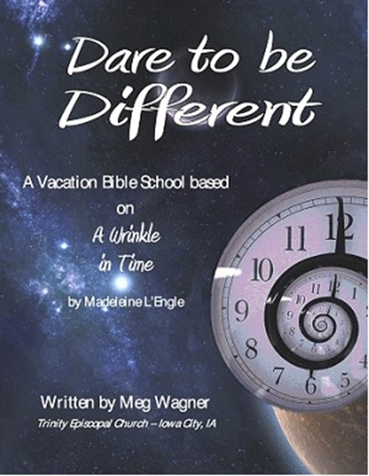

Vacation Bible School

June 18th – 21nd, 2018 9am to noon

**Rising kindergarten thru 5th graders.**

**VBS will begin & conclude each day in Daniel Hall.**

**Based on a “Wrinkle in Time”**

***Special VBS for 3-4 year old children on***

***Monday & Tuesday only 9am to noon.***

**VBS Registration forms available in the church office or on the church website. Return completed forms to the church office.**

**Church Office**: Phone - 706.291.9111 Fax - 706.232.5007 Email: [elizabeth@stpetersrome.org](mailto:elizabeth@stpetersrome.org)

**Mail Address: 101 East Fourth AVENUE, Rome GA 30161**

**Office Hours:** Monday – Thursday 8am to 4pm and Friday 9am to 12 noon

**Connect on Facebook:** St Peter’s Episcopal Church, St Peter’s Sunday School,

St. Peter’s Rome EYC, & St. Peter’s Junior Choir

**Pictorial Directory** on your mobile device app tpcmobile.com or

on your computer www.theportraitcafe.com/churchdirectories.

[**www**.stpetersrome.org](http://www.stpetersrome.org)