

**ANNOUNCEMENTS**

**May 27, 2018**

***“Enter reverently, meditate quietly, worship devoutly, leave gratefully, serve Christ faithfully.”***

**WELCOME TO ALL OUR VISITORS!**  If you are interested in knowing more about St. Peter’s, please see an usher or one of the greeters who stand with the clergy after the service.

**TODAY AT ST. PETER'S**

8:30 am Holy Eucharist Rite II

9:00 am Breakfast

10:00 am Holy Eucharist Rite II (Nursery available)

1:00 pm Holy Eucharist Rite II in Spanish, Chapel

**LOOKING AHEAD:**

Tuesday/ May 22 **11am Yoga**

**12:15pm Healing Service**

Wednesday/May 23 **5:30pm Celtic Service**

**LAY MINISTERS:** (8:30) Reader/Prayers/Chalice Bearer – Mark Jester.

(10:00) 1st Lesson- Keith Summerlin; 2nd Lesson– Randy Muller; Prayers – Brian Hampton. Chalice Bearers –Beth Hughes, Tom Dasher, Glenn Segrest, Annette Morris.

**ALTAR CANDLES** are given by Nancy and Jack Knight to the Glory of God and in memory of Jean McRae and Pistol Knight.

**ALTAR FLOWERS** are given by Billie Abney and Sara Clark to the Glory of God and in memory of Billie’s parents Bill & Martha Abney Fricks and Judge W.L. & Lillian Abney.

**CHAPEL FLOWERS** are given by Tom Dasher and Jim Noon to the Glory of God and in memory of Robert A. Noon, Jim’s brother.

**INTERCESSORY PRAYER LIST** Mike Alexander, Neil Sanders, Fran Bagley, Regan Hice, Suzanne Black, Bryant Steele, Jim Hamrick, Nell Hamrick, Barnes Coble, Jerry Watford, Dan Dixon, Michael Foster, Patrick Cash, Katie Cooper Liley, Dale Holloway and those who provide them care.

If you or someone you know is hospitalized or in need of clergy, home communion meals or flowers, please notify the CHURCH OFFICE 706.291.9111 or e[lizabeth@stpetersrome.org](mailto:lizabeth@stpetersrome.org).

Remember area hospitals & care facilities do NOT notify us with their admissions.

*To add a name to the PRAYER LIST or MILITARY LIST, contact the church office. The prayer list will be refreshed the 1st Sunday of every month.*

**Happy Birthday** to those celebrating birthdays (May 20 – May 26) Constance Ortmeier, Bob Steinbruegge, Remy Jennings, Nancy Starr, Madge Crawford, Dick Ingram, Gus Gandy, Becky Sims, Julie Lucas, John Hine, Frank Minor and

Jacob Bressette.



**MEMORIAL DAY – A special salute to all of our fallen Americans.**

Especially those that served in WWI as this is their 100th Anniversary.

The Church office will be closed tomorrow, Monday May 28th.



SAVE THE DATE - June 27th 6pm

ST. PETER’s Day CELEBRATION

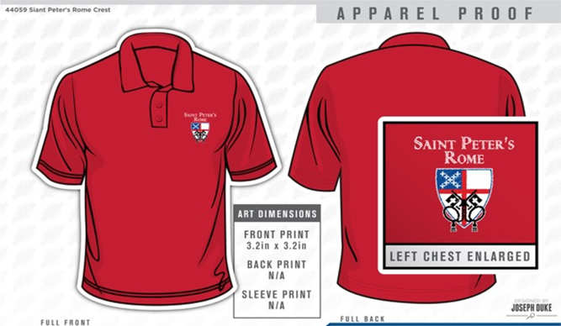

**GET YOUR RED ON!**

Limited sizes available, childs to 2XL. Call the Church office NOW to get your very own St. Peter’s Logo Polo shirt. ONLY $25 and it will come in handy next month for St. Peter’s Day!

Memorial Service for **Gryphon** Varidel will be held in the

Pet Garden of St. Peter’s TODAY at 11:30am.

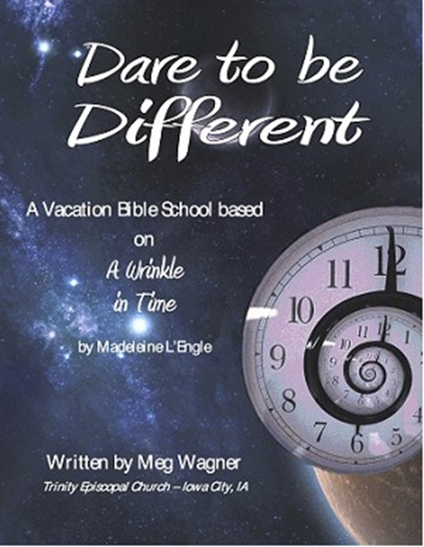Vacation Bible School

“Dare to be Different”

June 18th – 21nd, 2018 9am to noon

**Rising kindergarten thru 5th graders.**

**VBS will begin & conclude each day in Daniel Hall.**

**Based on book “A Wrinkle in Time”**

***Special VBS for 3-4 year old children on***

***Monday & Tuesday only 9am to noon.***

**VBS Registration forms available:**

* **Church office**
* **Website** [**www.stpetersrome.org**](http://www.stpetersrome.org)

**Return completed forms to the church.**



**VBS DECORATING BLITZ**

**June 6th 10am-2pm**

**We need YOUR help!**

**VBS VOLUNTEERS – EYC through Adult**

VBS is the #1 event for our kids, and we always have a blast each summer!  Would you consider coming to lend a hand during VBS week? We have all kinds of jobs to fit every skill set.

Our kids love hanging out with the BIG KIDS of EYC!

**Come make a difference in the life of our young people.**

Email [stpetersromefamily@gmail.com](mailto:stpetersromefamily@gmail.com) or call/text 706.266.1131 or 706.512.9193

**CHILDREN’S CORNER!**

**Pentecost Sunday**

**Nursery/Toddler care is available** and is located on the 2nd floor of the Education Building beginning at 9:45am.



**If your younger children are staying with you in the pew during service, we are delighted to have the whole family joining us in worship.**

**Little ones are always welcome**.

**For Busy Little Hands in Church:** We provide scriptural coloring sheets, crayons, and a children’s guide to the Eucharist, in the back of the church to help children in understanding our scripture readings and our corporate worship.

**BREAK for the SUMMER –** Programs/activities that will suspend during the summer months are listed below with dates for their **final** meeting.

May 9th Children & Youth Sunday School

May 9th Wednesday Night meal & EYC activities

May 13th Children’s Chapel

May 17th Thursday Bible Study

May 20th Adult Formation & Coffee/Conversation

June 24th Sunday Morning Breakfast

**Chair Yoga** Break from July 4th – August 1st.

**Centering Prayer** Break April 19th thru June 6th.

**Church Office**: Phone - 706.291.9111 Fax - 706.232.5007 Email: [elizabeth@stpetersrome.org](mailto:elizabeth@stpetersrome.org)

**Mail Address: 101 East Fourth AVENUE, Rome GA 30161**

**Office Hours:** Monday – Thursday 8am to 4pm and Friday 9am to 12 noon

**Connect on Facebook:** St Peter’s Episcopal Church, St Peter’s Sunday School,

St. Peter’s Rome EYC, & St. Peter’s Junior Choir

**Pictorial Directory** on your mobile device app tpcmobile.com or

on your computer www.theportraitcafe.com/churchdirectories.

[**www**.stpetersrome.org](http://www.stpetersrome.org)

Take these announcements home to stay plugged in with St. Peter’s