

**ANNOUNCEMENTS**

**May 13, 2018**

***“Enter reverently, meditate quietly, worship devoutly, leave gratefully, serve Christ faithfully.”***

**WELCOME TO ALL OUR VISITORS!**  If you are interested in knowing more about St. Peter’s, please see an usher or one of the greeters who stand with the clergy after the service.

**TODAY AT ST. PETER'S**

8:30 am Holy Eucharist Rite II

9:00 am Breakfast

10:00 am Holy Eucharist Rite II (Nursery available)

10:00 am Children’s Chapel

11:15 am Adult & Youth Formation

11:15 am Conversation & Coffee

1:00 pm Holy Eucharist Rite II in Spanish, Chapel

**LOOKING AHEAD:**

Tuesday/ May 15 **11am Yoga**

**12:15pm Healing Service**

Wednesday/May 16 **5:30pm Celtic Service**

Thursday/May 17 **10am Bible Study**

**LAY MINISTERS:** (8:30) Reader/Prayers/Chalice Bearer – Rachel Jones.

(10:00) 1st Lesson- Andye Moss; 2nd Lesson– Alex Carlton; Prayers – Chris Edgeworth Chalice Bearers –Andye Moss, Brian Johnson, Alex Hodges, Curt Yarbrough.

**ALTAR CANDLES** are given by Nancy and Jack Knight to the Glory of God and in memory of Jean McRae and Pistol Knight.

**ALTAR FLOWERS** are given by Gordon Lee Hight to the Glory of God and in memory of Sue Ellenburg Hight, Charles & Alberta Hight, Irene Matthews Hight, and Gordon & Irene Hight.

**CHAPEL FLOWERS** are given by Andye Moss and the Drew Moss Family to the Glory of God and in memory of our Mothers and Grandmothers.

**INTERCESSORY PRAYER LIST** Mike Alexander, Neil Sanders, Fran Bagley, Regan Hice, Suzanne Black, Mildred Edgeworth, Bryant Steele, Jim Hamrick, Nell Hamrick, Barnes Coble, Jerry Watford, Dan Dixon, Jim Dixon, Michael Foster, Patrick Cash, Katie Cooper Liley and those who provide them care.

If you or someone you know is hospitalized or in need of clergy, home communion meals or flowers, please notify the CHURCH OFFICE 706.291.9111 or e[lizabeth@stpetersrome.org](mailto:lizabeth@stpetersrome.org).

Remember area hospitals & care facilities do NOT notify us with their admissions.

*To add a name to the PRAYER LIST or MILITARY LIST, contact the church office. The prayer list will be refreshed the 1st Sunday of every month.*

**Happy Birthday** to those celebrating birthdays (May 13 – May 19) Mary Louise Lever, Janet Flippen, Janice Holley-Houck, Jim McCallie, Christy Pruitt, Janice Wright, Sarah Beaucham, Dean Morgan, Shane O’Neill, Blair Moseley.

**ADULT FORUM**

**TODAY** Janet Byington will lead forum on the importance of Saints in our

daily lives and talk about St. Anthony.

**May 20** Peggy Nash will present a Missions Fair. This if the FINAL Adult

Forum for the summer.



**COFFEE & CONVERSATION** – Adults meet in the Rhodes Wyatt room following the 10am worship service for simple coffee & conversation.



**VBS WORKERS *“Dare to be Different”* –** Informational meeting will be held Next Sunday on May 20th at 4-5:30 pm in Daniel Hall.



SAVE THE DATE - June 27th 6pm

ST. PETER’s Day CELEBRATION

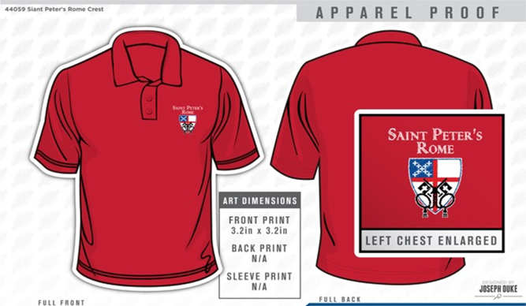**GET YOUR RED ON!**

Limited sizes available, child to 2XL. Call the Church office NOW to get your very own St. Peter’s Logo Polo shirt. ONLY $25 and it will come in handy next month for St. Peter’s Day!

Take these announcements home to stay plugged in with St. Peter’s

**WEDNESDAY PRAYER BEAD TIME CHANGE –** On Wednesday May 23rd the Prayer Bead group will meet **at 7pm** not their usual 6pm time.

**BREAK for the SUMMER –** Some of our programs/activities will suspend during the summer months. Below are the dates each of these programs will have their final meeting.



May 6th Children & Youth Sunday School

May 9th Wednesday Parish Meal & EYC activities

May 9th  Children’s Choir

May 13th Children’s Chapel

May 17th Thursday Bible Study

May 20th Adult Formation & Coffee and Conversation

**Chair Yoga** Break from July 4th – August 1st.

**Centering Prayer** Break April 19th thru June 6th.

Mission & Outreach for May

Hospitality House

The Hospitality House is a nonprofit organization providing emergency & outreach support services to the victims of domestic violence. There are 27 beds for women & their children. Other services provided by Hospitality House include: food, clothing, counseling, and legal advocacy.

During the month of May, we have been asked to donate the following items to the Shelter: **New bath towels, wash cloths, pillows, single size bed linens, women's underwear, and children's underwear.** Among other retail stores, these items may be purchased at good prices at Ollies, Big Lots, Wal Mart.

Non-perishable food items: **Canned food, cleaning supplies, facial tissue, bath tissue, paper towels, shampoo, conditioner, deodorant, and personal hygiene items.** These items can be purchased for good prices at Dollar Tree, Dollar General.

**Please bring these items to Daniel Hall.**

Take these announcements home to stay plugged in with St. Peter’s

**CHILDREN’S CORNER!**

**Seventh Sunday in EASTER**

**Nursery/Toddler care is available** and is located on the 2nd floor of the Education Building for the 10am service, beginning at 9:45am.

**Children’s Chapel** – this is our final chapel before we break for the summer. See you all back in Chapel in August.

 **If your younger children are staying with you in the pew during service, we are delighted to have the whole family joining us in worship.**

**Little ones are always welcome**.

**For Busy Little Hands in Church:** We provide scriptural coloring sheets, crayons, and a children’s guide to the Eucharist, in the back of the church to help children in understanding our scripture readings and our corporate worship.

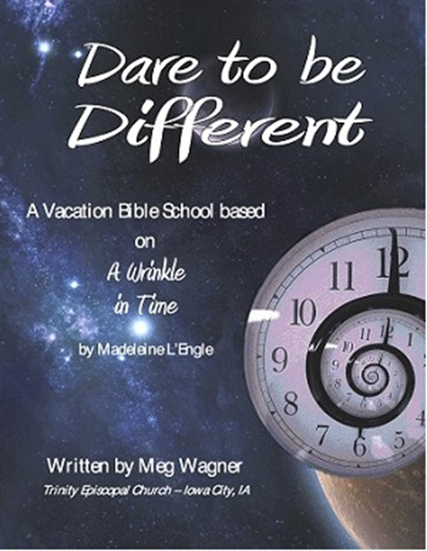

Vacation Bible School

June 18th – 21nd, 2018 9am to noon

**Rising kindergarten thru 5th graders.**

**VBS will begin & conclude each day in Daniel Hall.**

**Based on a “Wrinkle in Time”**

***Special VBS for 3-4 year old children on***

***Monday & Tuesday only 9am to noon.***

**VBS Registration forms available in the church office or on the church website.**

**Return completed forms to the church office.**

**Church Office**: Phone - 706.291.9111 Fax - 706.232.5007 Email: [elizabeth@stpetersrome.org](mailto:elizabeth@stpetersrome.org)

**Mail Address: 101 East Fourth AVENUE, Rome GA 30161**

**Office Hours:** Monday – Thursday 8am to 4pm and Friday 9am to 12 noon

**Connect on Facebook:** St Peter’s Episcopal Church, St Peter’s Sunday School,

St. Peter’s Rome EYC, & St. Peter’s Junior Choir

**Pictorial Directory** on your mobile device app tpcmobile.com or

on your computer www.theportraitcafe.com/churchdirectories.

[**www**.stpetersrome.org](http://www.stpetersrome.org)