

**ANNOUNCEMENTS**

**April 8, 2018**

***“Enter reverently, meditate quietly, worship devoutly, leave gratefully, serve Christ faithfully.”***

**WELCOME TO ALL OUR VISITORS!**  If you are interested in knowing more about St. Peter’s, please see an usher or one of the greeters who stand with the clergy after the service.

**TODAY AT ST. PETER'S**

8:30 am Holy Eucharist Rite II

9:00 am Breakfast

10:00 am Holy Eucharist Rite II (Nursery available)

Children’s Chapel

11:15 am Formation – Children/Youth & Adults

Coffee & Conversation

11:30 am Family Ministries Meeting – Rhodes Wyatt

1:00 pm Holy Eucharist Rite II in Spanish, Chapel

**LOOKING AHEAD:**

Tuesday/ April 10 **11am Yoga**

**12:15pm Healing Service**

Wednesday/April 11 **5:30pm Celtic Service**

**5:45pm Parish Dinner**

**6:15pm Mikell Magic**

**6:30pm Episcopal 101 Class**

**7:15pm EYC Activities & Pizza**

Thursday/April 12 **10am Bible Study**

**6:30pm Centering Prayer**

**LAY MINISTERS:** (8:30) Reader/Prayers/Chalice Bearer – Mark Jester. (10:00) 1st Lesson –Brian Hampton; 2nd Lesson – Keith Summerlin; Prayers –Randy Muller; Chalice Bearers –Annette Morris, Allien McNair, Andye Moss, Tom Dasher.

**ALTAR CANDLES** are given by Nancy Prall to the Glory of God and in memory of Jo and Warren Prall.

**ALTAR FLOWERS** are given by Fran & Harris Bagley to the Glory of God and in loving memory of their parents, Mr. & Mrs. Ralph Benjamin Burt and Mr. & Mrs. Earl G. Bagley.

**INTERCESSORY PRAYER LIST** Mike Alexander, Neil Sanders, Fran Bagley, Jack Edgens, June Dellis, Alicia Segars, Regan Hice, Suzanne Black, Mildred Edgeworth, Bryant Steele, Jim Hamrick, Nell Hamrick, Ronnie Mixon, Norma Littlejohn, Eliza Paris, Steve Conrad, Christie Thomason, Brenda Melton, Jay Langley, Delores Nowell, Barnes Coble and those who provide them care.

*To add a name to the PRAYER LIST or MILITARY LIST, contact the church office. The prayer list will be refreshed the 1st Sunday of every month.*

**SYMPATHY OF THE PARISH** extended to friends and family of Enloe Willingham who died on April 4, 2018.

**Happy Birthday** to those celebrating birthdays (April 8- April 14). June Dellis, Sammy Edgeworth, Wilson Lucas, Nell Warren, Sarah McElrath, Louise Branham, Jimmy Smith, Joel Ellis, Lamar Wyatt, Sarah Hardaker, Andy Anderson.



**In our pulpit today….**

Reverend Devon Goddard Smyth is a United Methodist minister. She currently fulfills her ministry appointment as the Executive Director of William S. Davies Shelters, Inc. She is a graduate of Warren College and Duke Divinity School. Devon and her husband, David have two children, Katie-Wimberly (20) and Bennett (12).

**DON’T MISS WEDNESDAY ACTIVITIES THIS WEEK**



**PARISH DINNER – 4/11/2018 at 5:45**

Mini Meatloaves/Mashed potatoes/roasted Brussel sprouts/fruit bowl. Lemon Bundt cake for dessert. Adults $5, children $3 family maximum $20.

Call or email the office by **NOON on Tuesday** with your reservation.

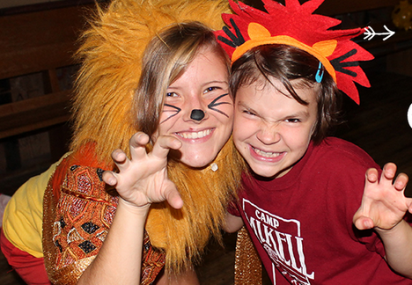**MIKELL MAGIC Night?**

Do you know about Mikell Magic?  Make plans to join us Wednesday, **April 11 from 6:15-7:00** in Daniel Hall to hear, Easton Davis talk about our diocesan treasure in beautiful Toccoa.  Summer Camps are available for rising 1st graders through seniors, but the fun doesn’t stop there.  Mikell is a special place for kids of all ages.

Let us know if you will need childcare that night as well by NOON on April 7!

**ADULT FORUM for April**

4/8/2018 Brian Hampton continues study of the Apostle Paul

4/15/2018 Brian Hampton concludes study of the Apostle Paul

4/22 & 29 No Adult Forum



**COFFEE & CONVERSATION** – Join with other adults in Rhodes Wyatt Room after the 10am worship service for simply conversation and coffee.

**LATER IN APRIL….**

* Canterbury Sunday April 15th
* Youth Sunday/Seniors Honored April 22nd
* Bishops Visit with Confirmations

April 29th

**LIVING COMPASS – Beginning May 7th** Living Compass presents **“Using Prayer beads to deepen your connection with God”**

3-week class offered on Mondays or Wednesdays.

You will make Prayer Beads and learn how they have been used historically. The tactile sensation of holding the bead can be used as a centering practice that blends well with centering prayer techniques, yoga or any time of prayer

**If you are interested in attending, please contact D’Ann Downey ahead of time at**

[**ddowneywarley@comcast.net**](mailto:ddowneywarley@comcast.net) **or 706.266.3444.**

**Order your kit at least 2 WEEKS in advance from: www.prayerworksstudio.etsy.com**

Take these announcements home to stay plugged in with St. Peter’s

**Church Office**: Phone - 706.291.9111 Fax - 706.232.5007 Email: [elizabeth@stpetersrome.org](mailto:elizabeth@stpetersrome.org)

**Mail Address: 101 East Fourth AVENUE, Rome GA 30161**

**Office Hours:** Monday – Thursday 8am to 4pm and Friday 9am to 12 noon

**Connect on Facebook:** St Peter’s Episcopal Church, St Peter’s Sunday School,

St. Peter’s Rome EYC, & St. Peter’s Junior Choir

**Pictorial Directory** on your mobile device app tpcmobile.com or

on your computer www.theportraitcafe.com/churchdirectories.

[**www**.stpetersrome.org](http://www.stpetersrome.org)

**CHILDREN’S CORNER!**

**Second Sunday in EASTER**

**Nursery/Toddler care is available** and is located on the 2nd floor of the Education Building for the 10am service, beginning at 9:45am.

**Children’s Chapel** is available for children ages pre-k through 3rd grade during the 10am worship service on the 2nd floor of the Education Building.

 **If your younger children are staying with you in the pew during service, we are delighted to have the whole family joining us in worship.**

**Little ones are always welcome**.

**For Busy Little Hands in Church:** We provide scriptural coloring sheets, crayons, and a children’s guide to the Eucharist, in the back of the church to help children in understanding our scripture readings and our corporate worship.

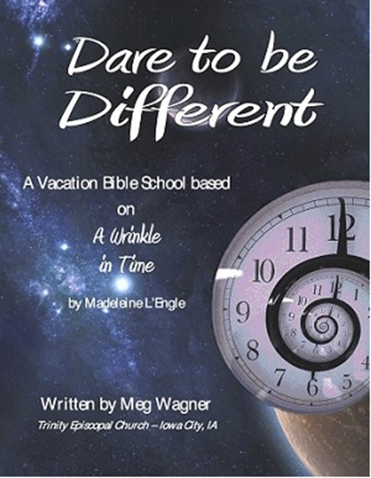

SAVE THE DATE….

Vacation Bible School

June 18th – 21nd, 2018 9am to noon

**Rising kindergarten thru 5th graders.**

**VBS will begin & conclude each day in Daniel Hall.**

**Based on a “Wrinkle in Time”**

***Special VBS for 3-4 year old children on***

***Monday & Tuesday only 9am to noon.***