

**ANNOUNCEMENTS**

**April 22, 2018**

***“Enter reverently, meditate quietly, worship devoutly, leave gratefully, serve Christ faithfully.”***

**WELCOME TO ALL OUR VISITORS!**  If you are interested in knowing more about St. Peter’s, please see an usher or one of the greeters who stand with the clergy after the service.

**TODAY AT ST. PETER'S**

8:30 am Holy Eucharist Rite II

9:00 am Breakfast

10:00 am Holy Eucharist Rite II (Nursery available)

Children’s Chapel

11:15 am Formation – Children/Youth & Adults

Coffee & Conversation

1:00 pm Holy Eucharist Rite II in Spanish, Chapel

**LOOKING AHEAD:**

Tuesday/ April 10 **11am Yoga**

**12:15pm Healing Service**

Wednesday/April 11 **5:30pm Celtic Service**

**5:45pm Parish Dinner**

**7:15pm EYC Activities & Pizza**

Thursday/April 12 **10am Bible Study**

**6:30pm Centering Prayer**

**LAY MINISTERS:** (8:30) Reader/Prayers/Chalice Bearer – Rachel Jones.

(10:00) 1st Lesson- Denton Vargo; 2nd Lesson– Camille Trammell; Prayers– Claire Anderson; Chalice Bearers –Sunny Knauss, Beth Hughes, Brian Hampton, Curt Yarbrough.

**ALTAR CANDLES** are given by Nancy Prall to the Glory of God and in memory of Jo and Warren Prall.

**ALTAR FLOWERS** are given by the Jimmy Smith family and Kathryn Smith to the Glory of God and in memory of departed loved ones.

**CHAPEL FLOWERS** are given by Laura Frederick to the Glory of God and in memory of Donald and other family members.

**INTERCESSORY PRAYER LIST** Mike Alexander, Neil Sanders, Fran Bagley, Jack Edgens, June Dellis, Alicia Segars, Regan Hice, Suzanne Black, Mildred Edgeworth, Bryant Steele, Jim Hamrick, Nell Hamrick, Ronnie Mixon, Norma Littlejohn, Eliza Paris, Steve Conrad, Christie Thomason, Brenda Melton, Jay Langley, Delores Nowell, Barnes Coble, Sasa Vance, Patrick Cash & Family, Phil Herron, Marshela Segars and those who provide them care.

If you or someone you know are hospitalized or in need of clergy, home communion or meals, please notify the CHURCH OFFICE 706.291.9111 or e[lizabeth@stpetersrome.org](mailto:lizabeth@stpetersrome.org).

Remember area hospitals & care facilities do NOT notify us with their admissions.

*To add a name to the PRAYER LIST or MILITARY LIST, contact the church office. The prayer list will be refreshed the 1st Sunday of every month.*

**Happy Birthday** to those celebrating birthdays (April 22- April 28). Madeline Trammell, Drew Bressette, Benjamin McElrath, Ivey Sirmans, Barbara Dixon, Alix Warren, Julia Douglas, Keith Summerlin, Sara Pickett, and Jack Bell

**PARISH DINNER – 4/25/2018 at 5:45**

Garlic herb pork roast, carrots/onions/tomatoes, mashed potatoes, layered salad, Apple Spice cake. Adults $5, children $3 family maximum $20.

Call or email the office by **NOON on Tuesday** with your reservation.

**YOUTH SUNDAY –** Many thanks to the youth that are assisting in readings, prayers and communion in the 10am worship service:

Homily Grant Sikes

Officiant Curry Teems

Torch Sophia Vargo and Ben Avery

Crucifer Josie Cole

Readers Denton Vargo & Camille Trammell

Prayers Claire Anderson

**ADULT FORUM for April**

4/22 Hollye Smith, review Family Ministries survey discuss future

****programming.

4/29 No Adult Forum

**COFFEE & CONVERSATION** – Join with other adults in Rhodes Wyatt Room after the 10am worship service for simply conversation and coffee.

**LIVING COMPASS – Beginning May 7th** Living Compass presents

**“Using Prayer beads to deepen your connection with God”**

3-week class offered on Mondays or Wednesdays.

You will make Prayer Beads and learn how they have been used historically. The tactile sensation of holding the bead can be used as a centering practice that blends well with centering prayer techniques, yoga or any time of prayer.

**If you are interested in attending, please contact D’Ann Downey ahead of time at**

[**ddowneywarley@comcast.net**](mailto:ddowneywarley@comcast.net) **or 706.266.3444.**

**Order your kit at least 2 WEEKS in advance from: www.prayerworksstudio.etsy.com**

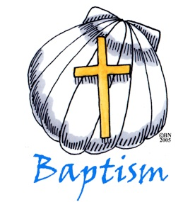

**Baptism** If you are interested in having your child baptized the next date will be **May 20th.** Please contact the church office to obtain paperwork and details.

**PILGRIMS FOR HIRE –**

**Do you have a job around the house or yard that you need help to tackle?**

Our Youth are ready to go to work.

No direct payment required, simply make a donation of your choice to the Youth Pilgrimage to Italy.

Contact the church office or Mother Nikki with the task you need completed.



Mission & Outreach for April

Faith & Deeds Clinic

This month we are asking parishioners to support the efforts of The Faith & Deeds Clinic. The clinic is under new management and has re-organized. The budget is $130,000 a year, compared to $250,000 a few years ago. The clinic’s needs are many. We can help by donating the following items: **Paper Towels Copy Paper Toilet Paper Lysol Wipes Lysol Spray**

**Small Dixie bathroom cups Monetary donations**



**They also need Volunteer:**

**Doctors, Nurses and Translators.**

Bring donations to the CHURCH.

Checks payable to St. Peter’s with memo “Faith & Deeds”

**Volunteer opportunities:**

Good Neighbor Ministries Contact Nancy Hunter 706.506.3889

Restoration Rome Clothes Closet Fridays 9 am-noon. Jeanne Mathews 706.676.1039

Community Kitchen April 20th & 24th Andye Moss 706.506.4695

Take these announcements home to stay plugged in with St. Peter’s

**Church Office**: Phone - 706.291.9111 Fax - 706.232.5007 Email: [elizabeth@stpetersrome.org](mailto:elizabeth@stpetersrome.org)

**Mail Address: 101 East Fourth AVENUE, Rome GA 30161**

**Office Hours:** Monday – Thursday 8am to 4pm and Friday 9am to 12 noon

**Connect on Facebook:** St Peter’s Episcopal Church, St Peter’s Sunday School,

St. Peter’s Rome EYC, & St. Peter’s Junior Choir

**Pictorial Directory** on your mobile device app tpcmobile.com or

on your computer www.theportraitcafe.com/churchdirectories.

[**www**.stpetersrome.org](http://www.stpetersrome.org)

**CHILDREN’S CORNER!**

**Fourth Sunday in EASTER**

**Nursery/Toddler care is available** and is located on the 2nd floor of the Education Building for the 10am service, beginning at 9:45am.

**Children’s Chapel** is available for children ages pre-k through 3rd grade during the 10am worship service on the 2nd floor of the Education Building.

 **If your younger children are staying with you in the pew during service, we are delighted to have the whole family joining us in worship.**

**Little ones are always welcome**.

**For Busy Little Hands in Church:** We provide scriptural coloring sheets, crayons, and a children’s guide to the Eucharist, in the back of the church to help children in understanding our scripture readings and our corporate worship.

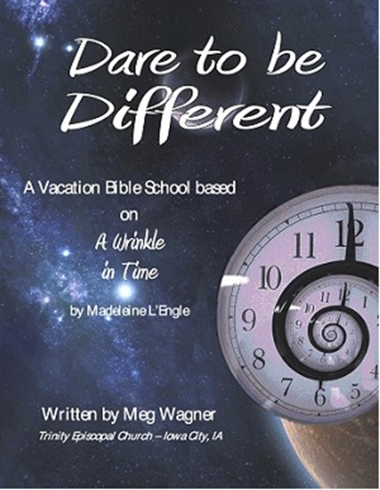

SAVE THE DATE….

Vacation Bible School

June 18th – 21nd, 2018 9am to noon

**Rising kindergarten thru 5th graders.**

**VBS will begin & conclude each day in Daniel Hall.**

**Based on a “Wrinkle in Time”**

***Special VBS for 3-4 year old children on***

***Monday & Tuesday only 9am to noon.***

**VBS Registration forms available in the church office or on the church website. Return completed forms to the church office.**