

**ANNOUNCEMENTS**

**March 25, 2018**

***“Enter reverently, meditate quietly, worship devoutly, leave gratefully, serve Christ faithfully.”***

**WELCOME TO ALL OUR VISITORS!**  If you are interested in knowing more about St. Peter’s, please see an usher or one of the greeters who stand with the clergy after the service.

**TODAY AT ST. PETER'S**

8:30 am Holy Eucharist Rite I

9:00 am Breakfast

10:00 am Holy Eucharist Rite II (Nursery available)

Children’s Chapel

11:15 am Coffee & Conversation – Rhodes Wyatt

1:00 pm Holy Eucharist Rite II in Spanish, Chapel

**LOOKING AHEAD:**

Monday / March 26 **Holy Week Service 12 noon & lunch**

Tuesday/ March 27 **Holy Week Service 12 noon & lunch**

Wednesday/March 28 **Holy Week Service 12 noon & lunch**

**Celtic Service 5:30 pm**

**Parish Dinner 5:45 pm**

Thursday/March 29 **Maundy Thursday 7pm**

Friday/March 30 **Good Friday Service 12 noon**

Saturday/March 31 **Easter Vigil 9pm, reception to follow**

**LAY MINISTERS:** (8:30) Reader/Prayers/Chalice Bearer – Tricia Richards;

(10:00) 1st Lesson –Chris Edgeworth; 2nd Lesson –Norman Fletcher; Prayers –Bob Berry; Chalice Bearers –Sunny Knauss, Annette Morris, Stephen Patton, Brian Hampton.

**INTERCESSORY PRAYER LIST** Mike Alexander, Neil Sanders, Fran Bagley, Jack Edgens, June Dellis, Alicia Segars, Jamie Hughes, Regan Hice, Suzanne Black, Mildred Edgeworth, Bryant Steele, Pete & Helen Grosch, Kate Trette, Medford School students & staff, Kathy Rood, Barnes Coble, Steve Stutts, Bill Knight, Jim Hamrick, Christie Thomason, Diana Dumas, Matthew Breese, Julia Hodges, Steve Conrad, Nell Hamrick Patrick Cash & family, Matthew Black and those who provide them care.

*To add a name to the PRAYER LIST or MILITARY LIST, contact the church office. The prayer list will be refreshed the 1st Sunday of every month.*

**Happy Birthday** to those celebrating birthdays (March 25 – April 1) Peg Avery, Paula Dickinson, Clem Trammell, Steve Stutts, McAllister June.

**ADULT FORUM**

* March 25th & April 1st – Adult form will NOT meet.



**ADULTS –** join others in the Rhodes Wyatt room following the 10am service for simple Coffee & Conversation.

**WEDNESDAY PARISH DINNER – 3/28/2018 at 5:45**

Chicken Fajitas with all the fixings, Chess Cake for dessert. Adults $5, children $3 family maximum $20. Call or email the office by **NOON on Tuesday** with your reservation or to make changes to your standing reservation.



**VOLUNTEER OPPORTUNITIES:**

**Good Neighbor Ministries**

Contact Nancy Hunter 706.506.3889

**Community Kitchen**

April 20th & 24th Contact Andye Moss 706.506.4695

**Restoration Rome Clothes Closet**

Fridays 9 am to noon Contact Jeanne Mathews, 706.676.1039

**Next week the following programs will NOT meet:**

* **Tuesday** Yoga and Healing Service will NOT meet.
* **Wednesday** EYC and Episcopal 101 class will NOT meet.
* **Thursday** Bible Study and Centering Prayer will NOT meet.



**Holy Week & Easter Services**

Community Services & lunch March 26th – 28th at noon Hosted by St. Peter’s

Maundy Thursday March 29th 7 pm

Good Friday March 30th noon

Easter Vigil March 31st 9 pm, reception to follow in Daniel Hall

Easter Services April 1st 9 am and 11:15 am

9am Easter Morning service will be broadcast

**EASTER ACTIVITIES…**

* Bring fresh flower stems & greenery to adorn the Cross of Flowers in front of the church on Easter Sunday!
* Bring your Mite Boxes with donations to Episcopal Relief & Development



Easter Morning from 10-11am a light breakfast and Hot Cross buns will be served in Daniel Hall.

**Easter Egg Hunt** next Sunday following the 9am worship service. Feel free to bring your Easter basket or gift bags will be provided.

Take these announcements home to stay plugged in with St. Peter’s

**CHILDREN’S CORNER!**

**Palm Sunday**

**Nursery/Toddler care is available** and is located on the 2nd floor of the Education Building for the 10am service, beginning at 9:45am.

**Children’s Chapel** is available for children ages pre-k through 3rd grade during the 10am worship service on the 2nd floor of the Education Building.

 **If your younger children are staying with you in the pew during service, we are delighted to have the whole family joining us in worship.**

**Little ones are always welcome**.

**For Busy Little Hands in Church:** We provide scriptural coloring sheets, crayons, and a children’s guide to the Eucharist, in the back of the church to help children in understanding our scripture readings and our corporate worship.

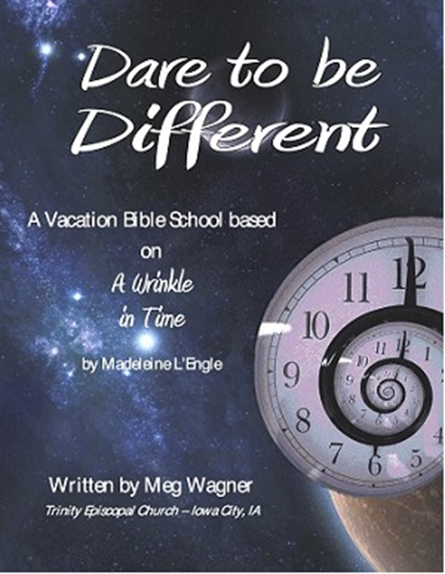

SAVE THE DATE….

Vacation Bible School

June 18th – 21nd, 2018 9am to noon

**Rising kindergarten thru 5th graders.**

**VBS will begin & conclude each day in Daniel Hall.**

**Based on a “Wrinkle in Time”**

***Special VBS for 3-4 year old children on***

***Monday & Tuesday only 9am to noon.***

**Church Office**: Phone - 706.291.9111 Fax - 706.232.5007 Email: [elizabeth@stpetersrome.org](mailto:elizabeth@stpetersrome.org)

**Mail Address: 101 East Fourth AVENUE, Rome GA 30161**

**Office Hours:** Monday – Thursday 8am to 4pm and Friday 9am to 12 noon

**Connect on Facebook:** St Peter’s Episcopal Church, St Peter’s Sunday School,

St. Peter’s Rome EYC, & St. Peter’s Junior Choir

**Pictorial Directory** on your mobile device app tpcmobile.com or

on your computer www.theportraitcafe.com/churchdirectories.

**www**.stpetersrome.org