ANNOUNCEMENTS
December 10, 2017
“Enter reverently, meditate quietly, worship devoutly, leave gratefully, serve Christ faithfully.”

WELCOME TO ALL OUR VISITORS! If you are interested in knowing more about St. Peter’s, please see an usher or one of the greeters who stand with the clergy after the service.

TODAY AT ST. PETER'S
8:30 am Holy Eucharist Rite I
9:00 am Breakfast
10:00 am Holy Eucharist Rite II (Nursery available)
Children’s Chapel
11:15 am Formation for Adults, Youth & Children

LOOKING AHEAD:

Tuesday/ Dec 12 Healing Service 12:15pm
Living Compass Advent 1pm
Canterbury Club 5pm Berry
Wednesday/Dec 13 Celtic Service 5:30
Parish Dinner 5:45
Living Compass Advent 6pm
EYC – 6:30 Schroeder’s
Thursday/Dec 14 Blue Christmas Eucharist 5:30
Centering Prayer 6:30pm
Friday/Dec 15 Youth Lock In 6:30
Restoration Rome 9am to noon

LAY MINISTERS: (8:30) Reader/Prayers/Chalice Bearer – Rachel Jones;
(10:00) 1st Lesson –Betsy Awsumb; 2nd Lesson – Beth Hughes; Prayers – Randy Muller; Chalice Bearers –Bryan Johnson, Keith Summerlin, Curt Yarbrough, Beth Hughes.

ALTAR CANDLES are given by the Wesley Martin Family to the Glory of God and in memory of W.C. Owen and Kiki Petropole.

ADVENT CANDLES are given by Carol McCann to the Glory of God and in memory of Mr. and Mrs. Hubert Johnson and Bill Johnson.

ALTAR ARRANGEMENTS are given by Beth and Terry Hughes to the Glory of God and in memory of departed loved ones.

CHAPEL ARRANGEMENTS are given by Irby Ledbetter and her family to the Glory of God and in memory of Al Ledbetter.

INTERCESSORY PRAYER LIST Charlie Rutledge, Mike Alexander, Neil Sanders, Fran Bagley, Jack Edgens, June Dellis, Alicia Segars, Jamie Hughes, Mildred Edgeworth, Ivey Sirmans, Wade Carpenter, Andye Moss, Oliver Cooper, Sasa Vance, Regan Hice, Mark Rosenburg, Kate, Helen & Pete Grossch, Karl Bartley, Lindsay Harris, Angela Rhodes, Wayne Johnston, Bryant Steele and those who provide them care.

To add a name to the PRAYER LIST or MILITARY LIST, contact the church office. The prayer list will be refreshed the 1st Sunday of every month.

SYMPATHY OF THE PARISH extended to Kathy Steinbruegge on the death of her father, Dr. William Ralph Volger on December 2, 2017.

Happy Birthday to those celebrating birthdays (December 10 – December 16)
Lynette Bonner, Alice Enloe, Emily Robinson, Hank Crawford, Andrew McDaniel, Ave Rivera, Jacquelyn Mooney, Sophie June, Ronnie Mixon, Anna Nichols, Jeff Bohike, Charlie Beauchamp, Roger Smith, Meredith Cole, and Megan Massey.

CANTERBURY CLUB –
- CHEFS needed for the Spring Semester – if you feel called to prepare a home cooked meal for our Tuesday evening meetings, please call Rebecca Segrest 706.331.6363

MISSION & OUTREACH – December
Volunteer your time….

Toys for Tots Monday-Friday 9am-noon, Community Bldg Fairgrounds
Community Kitchen 22nd and 26th . Two shifts 8:30-10:15 OR 10:15-12:00
Restoration Rome Fridays from 9am to noon, Jeanne Mathews 706.676.1039

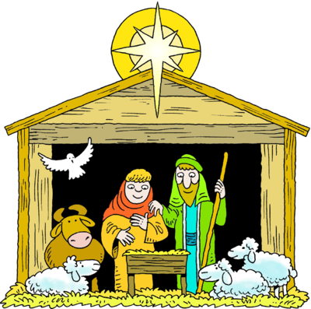
CHILDREN’S CHRISTMAS PAGEANT 12/20/2017
at 6:30pm following dinner served at 5:45pm.

Calling all CHILDREN… We need YOU for the pageant!

- Speaking and non-speaking parts.
- Angels, lambs, wise men, shepherds
- Mary, Joseph and a star.
- All are needed and can participate.
- Adult volunteers to assist before & night of the pageant.

Call Mother Nikki or the church office.

PARISH DINNER – Wednesday December 13th, Special Holiday Meal.
Bacon wrapped Pork Loin stuffed with cranberry/orange compote. Green Beans, Potatoes, Corn.
Homemade Coconut cake or Chess Pie. Vegetarian options available.
Call office by NOON on Tuesday with your reservation. Adults $5, Children $3 Family Max $20

ADVENT & CHRISTMAS SCHEDULE

WEDNESDAY, December 20th
5:45 p.m. Wednesday dinner
6:30 p.m. Children’s Christmas Pageant

SUNDAY, DECEMBER 24TH
8:30 a.m. and 10 a.m. Eucharists will be celebrated.

EVE OF THE NATIVITY on SUNDAY, DECEMBER 24TH
4:30 p.m. Children perform pre-music selections.
5:00 p.m.
11:00 p.m. with incense

MONDAY, DECEMBER 25TH - CHRISTMAS DAY SERVICE
Rite II Eucharist in the Chapel at 10 a.m.
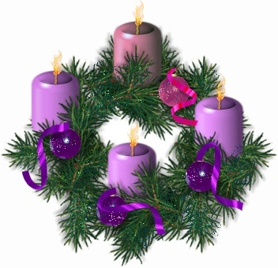

ADVENT SUPPLIES – A complete Advent Wreath kit is available for $10 or if you just need new Advent candles they are $5. Both are available in Daniel Hall TODAY. Proceeds go to support the Youth Pilgrimage Trip to Italy.
PUT ST. PETER’S UNDER YOUR TREE – St. Peter’s logo sweatshirts and polo shirts available for sale in the church office. Sizes limited, call the office to check for your size. Sweatshirts $35 Polo shirts $25, all proceeds go to the Youth Pilgrimage to Italy.
Calling all Musical CHILDREN – If you would like to participate in the pre- music program on Christmas Eve by playing or singing a religious piece please contact either Wanda Cantrell 706.346.9659 or Dagmar Carlton 706.266.0616.
Family to Family Advent Event – Tonight
Chrismon making - All necessary materials will be provided. $5 per family. Crafting 4-5pm, service, simple supper. Questions Dagmar Schmitz Carlton 706.266.0616

BAPTISM – The next opportunity for baptisms will be Sunday January 7, 2018. Please contact the church office to complete necessary paperwork if you are planning a baptism on this date.
CHILDREN’S CORNER!
Second Sunday of Advent

Nursery/Toddler care is available and is located on the 2nd floor of the Education Building for the 10am service, beginning at 9:45am.

Children’s Chapel is available for children ages pre-k through 3rd grade during the 10am worship service on the 2nd floor of the Education Building.
If your younger children are staying with you in the pew during service, we are delighted to have the whole family joining us in worship.

Little ones are always welcome.

For Busy Little Hands in Church: We provide scriptural coloring sheets, crayons, and a children’s guide to the Eucharist, in the back of the church to help children in understanding our scripture readings and our corporate worship.
Wednesday 12/13/2017 Schroeder’s
meet at church 6:30pm. EYC is open to all students grades 6 to 12. Friends are Welcome!

YOUTH LOCK IN ------December 15th ------
Pizza, Snacks & STAR WARS MOVIE

$5 for Movie and $5 for Walmart run.
Drop off 6:30pm then parent pick up on Saturday at 9am.

Church Office: Phone - 706.291.9111 Fax - 706.232.5007 Email: elizabeth@stpetersrome.org
Office Hours: Monday – Thursday 8am to 4pm and Friday 9am to 12 noon
St Peter’s Episcopal Church/St Peter’s Sunday School/St. Peter’s Rome EYC
St. Peter’s Junior Choir
www.stpetersrome.org

