ANNOUNCEMENTS
November 5, 2017
“Enter reverently, meditate quietly, worship devoutly, leave gratefully, serve Christ faithfully.”

WELCOME TO ALL OUR VISITORS! If you are interested in knowing more about St. Peter’s, please see an usher or one of the greeters who stand with the clergy after the service.

TODAY AT ST. PETER'S
8:30 am Holy Eucharist Rite I
9:00 am Breakfast
10:00 am Holy Eucharist Rite II (Nursery available)
Children’s Chapel
11:15 am Formation – Adult, Youth & Children
5:00 pm Eucharist in Spanish in the Chapel

LOOKING AHEAD:

Monday/ Nov 6 Living Compass 1pm
Tuesday/ Nov 7 Chair Yoga 11am
Healing Service 12:15pm
Canterbury Club 5pm Berry
Wednesday/Nov 8 Celtic Service 5:30
Wednesday Dinner 5:45
EYC – Schroeder’s Deli
Living Compass 6:30
Thursday/Nov 9 Centering Prayer 6:30 pm
Friday/Nov 10 Restoration Rome 9am

LAY MINISTERS: (8:30) Reader/Prayers/Chalice Bearer – Tricia Richards;
(10:00) 1st Lesson –Bob Steinbruegge; 2nd Lesson – Andye Moss; Prayers – Len Woodward; Chalice Bearers –Allien McNair, Bryan Johnson, Keith Summerlin, Rebecca Segrest.

ALTAR CANDLES are given by Elizabeth and Roger Ard to the Glory of God and in thanksgiving for the life of Mary Ann Ard.
ALTAR ARRANGEMENTS are given by Irby Ledbetter and her family to the Glory of God and in memory of Al Ledbetter.

CHAPEL ARRANGEMENTS are given to the Glory of God and in memory of Moses Wright Dunwoody II.

INTERCESSORY PRAYER LIST Charlie Rutledge, Mike Alexander, Neil Sanders, Fran Bagley, Barbara Wyatt, Jack Edgens, June Dellis, Terry Morris, Alicia Segars, Cathy Varidel, Jamie Hughes, Kathy Rood, Carole Krummel, Steve Conrad, Miretta Wadopian, Linda Cummings, Beverly Kaylor, Mildred Edgeworth and those who provide them care.

To add a name to the PRAYER LIST or MILITARY LIST, contact the church office. The prayer list will be refreshed the 1st Sunday of every month.

SYMPATHY OF THE PARISH is extended to M.J. Chisholm on the death of her mother, Elizabeth Chisholm on October 28, 2017.

Happy Birthday to those celebrating birthdays (November 5 – November 10) Dale Holloway, Marion Shaw, Lillian Baggett, Helen Keaten, Piero Barba, Sue Anderson, Vickie Gilliam, John Paul Cooper, Shane Walley, Lucy Lansing, Rosa Kelley, Katherine Knight, and Curry Teems.
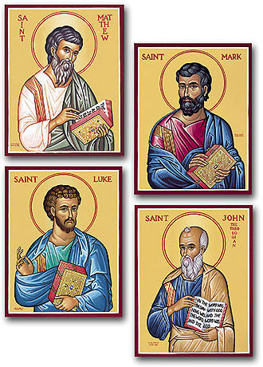

ADULT FORUM - Gospel Study
November 5th Wade Carpenter - Study of the book of Mark
November 12th No Sunday School due to church Annual Meeting
November 19th Leigh Patterson - Study of the book of Luke
November 26th Brian Hampton - Study of the book of Matthew
December 3rd John Kirkland - Study of the book of John

ANNUAL MEETING – Next Sunday, November 12th in Daniel Hall following the 10am Eucharist. Due to the Annual Meeting there will be NO FORMATION next Sunday.

LIVING COMPASS SURVEY – Please pick up the congregational survey, return completed surveys to the basket in Daniel Hall. Copies of the survey are located in Daniel Hall OR you can contact the church office.
WEDNESDAY PARISH MEAL – November 8th – Speak Cheesy Gourmet Grilled Cheese. Choose from: 1) Spinach, artichoke with tangy parmesan cheese 2) Toasted Pepperoni with mozzarella or 3) Classic grilled cheese. All served with chips, slaw and dessert. Reservations required by NOON on Tuesday. Adults $5, Children under ten $3, Family maximum $20.00

VOLUNTEER to HELP
Restoration Rome Fridays from 9am to 12noon work in the Clothes Closet.
Contact Jeanne Matthews 706.676.1039
Community Kitchen November 24th and 28th. 8:30am-10:15am OR 10:15am-12noon.
Contact Andye Moss agm614@aol.com

CANTERBURY CLUB – CALENDAR COLLECTION continues through December 11th. Bin located in Daniel Hall for your donations to assist DFACS.

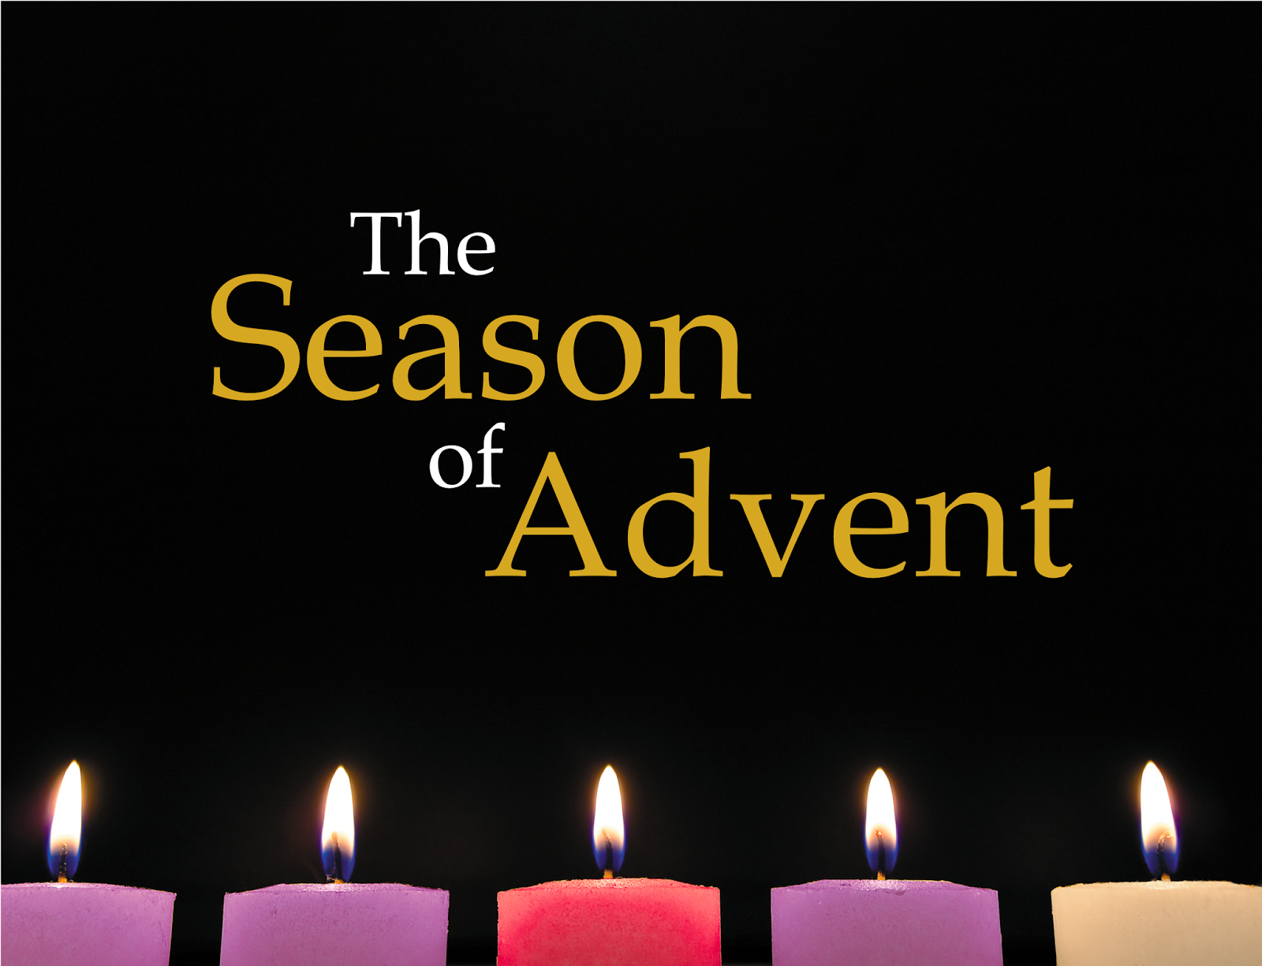

is coming make plans now…

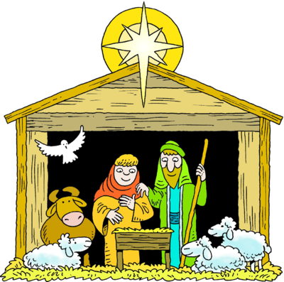
ADVENT PAGEANT December 20, 2017
VOLUNTEERS NEEDED:
Costume Helpers
Stage Hands
Craft Helpers

Contact the church office to volunteer your time and talent!
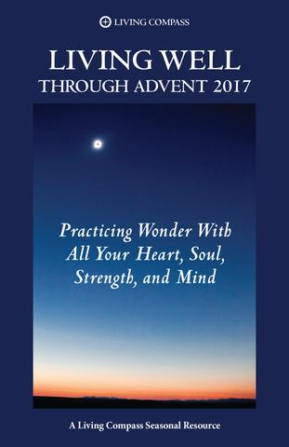

LIVING COMPASS presents a 4-week study “Practicing Wonder with all your Heart, Soul, Strength and Mind”. Classes available Monday or Wednesday.
Contact Beth Hughes (706.506.9636) or D’Ann Downey (706.266.3444) to register for this new study beginning the week of November 27th.

SUNDAY, DECEMBER 24TH
8:30 a.m. and 10 a.m. Eucharists will be celebrated.

EVE OF THE NATIVITY on SUNDAY, DECEMBER 24TH
5:00 p.m.
11:00 p.m. with incense

MONDAY, DECEMBER 25TH - CHRISTMAS DAY SERVICE
Rite II Eucharist in the Chapel at 10 a.m.

END OF THE YEAR – Stock or Mutual Funds
If you intend to gift stocks or mutual funds to St. Peter’s and desire it to be credited on your 2017 giving statement. Please begin the process EARLY so that the check is in the church office by noon on 12/29/2017.
CHILDREN’S CORNER!

All Saints Sunday

Nursery/Toddler care is available and is located on the 2nd floor of the Education Building for the 10am service, beginning at 9:45am.

Children’s Chapel is available for children ages pre-k through 3rd grade during the 10am worship service on the 2nd floor of the Education Building.

If your younger children are staying with you in the pew during service, we are delighted to have the whole family joining us in worship.

Little ones are always welcome.

For Busy Little Hands in Church: We provide scriptural coloring sheets, crayons, and a children’s guide to the Eucharist, in the back of the church to help children in understanding our scripture readings and our corporate worship.

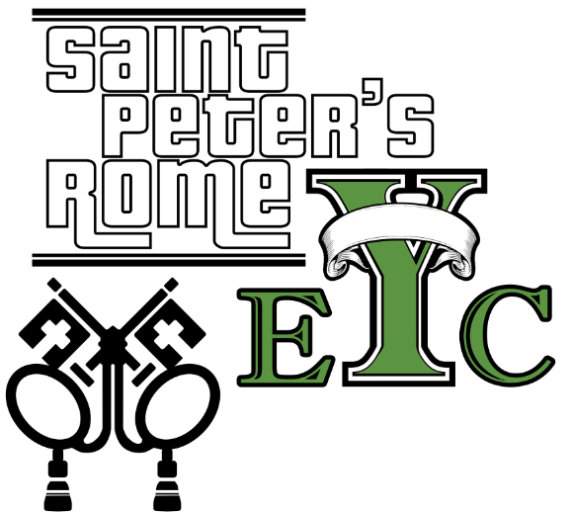
Wednesday, November 8th
Schroeder’s
EYC is open to all students grades 6 to 12.
Friends are Welcome!

GET CONNECTED!
Want to see what our small ones and youth are up to at St. Peter’s? Check out our Facebook pages: St. Peter’s Sunday School &
St. Peter’s Rome EYC.

Church Office: Phone - 706.291.9111 Fax - 706.232.5007 Email: elizabeth@stpetersrome.org
Office Hours: Monday – Thursday 8am to 4pm and Friday 9am to 12 noon
St Peter’s Episcopal Church/St Peter’s Sunday School/St. Peter’s Rome EYC
St. Peter’s Junior Choir
www.stpetersrome.org

