ANNOUNCEMENTS
January 29, 2017
“Enter reverently, meditate quietly, worship devoutly, leave gratefully, serve Christ faithfully.”

WELCOME TO ALL OUR VISITORS! If you are interested in knowing more about St. Peter’s, please see an usher or one of the greeters who stand with the clergy after the service.

TODAY AT ST. PETER'S
8:30 am Holy Eucharist Rite I
9:00 am Breakfast
10:00 am Holy Eucharist Rite II (Nursery available)
Children’s Chapel
11:15 am Wired Word, Adult & Youth Formation
Canterbury Club Lunch at Jerusalem Grill
4:00 pm EYC – Hiking to the House of Dreams!

LOOKING AHEAD:

January 30/Monday Canterbury Club 6 pm at Berry College
Praying in Color 1 pm at 401 E 4th Avenue
January 31/Tuesday Chair Yoga 11 am
Healing Service 12:15 pm
February 1/Wednesday Celtic Service
Adult & Children’s Choir rehearsal
Dinner
EYC – Yelling Bee 6:30 pm
February 2/Thursday Bible Study 10 am – Hebrews
Centering Prayer 6:30 pm

LAY MINISTERS: (8:30) Reader/Prayers/Chalice Bearer—Tricia Richards
(10:00) 1st Lesson—Janet Byington; 2nd Lesson—David Harvey; Prayers—Rebecca Roberts; Chalice Bearers—Bryan Johnson, Heidi Cole, Andye Moss, Brian Hampton.

CHURCH ALTAR ARRANGEMENTS are given by Ann Pullen, Clay Pullen, Mary George Pullen Livesay and Christopher Livesay to the Glory of God and in loving memory of William George Pullen.

INTERCESSORY PRAYER LIST – Rafael Carballo, Beth Hughes, Kathleen Bracken, Bill Fricks, Linda Cummings, Nancy Phillips, Carolyn Yongue, Barbara Wyatt, Jane Swanson, Charlie Rutledge, Mike Alexander, Neil Sanders, Delores Nowell, Wayne Johnston, Bonnie Reeder, Ron Schmidt, Malou Noth, Brandi Edgeworth, Sammy Edgeworth, Deseri Wooten, Sarah Wilbur, Jane Stegall Mosley, Ira Cole, Michael Foster, Pat York, Bill Segars, Len Woodward, Joel Jones Jr., David Duncan Family, Val Lancaster, Alice Wright, Louisa Johnston, Barbara Dixon and those who provide them care.

To add a name to the PRAYER LIST, contact the church office. Please note that the prayer list will be refreshed the first Sunday of every month. To renew your requests, please call or email the church office during the last week of the month.

SYMPATHY OF THE PARISH is extended to the Ramona and Greg Fricks on the death of Greg’s father, William “Bill” Fricks on January 20, 2017; and to the Steinbrueege family on the death of Kathy’s mother and Jamie and Robbie’s grandmother, Marilyn Rubio Vogler on January 25, 2017.

Happy Birthday to those celebrating birthdays (January 29 – February 4) Mary Burke Smith, Glenn Segrest, Ann Spears, Janet Morris, Beth Hughes, Toni King, Nash Cooper, Lauren Ledbetter, Bryan Schroeder, Denton Vargo, and Nancy McCallie.

WIRED WORD meets in the Rhodes-Wyatt room immediately following the 10:00 a.m. Eucharist. Each week we take an item from the news or current events and provide an opportunity to reflect on how our faith responds to or interacts with the concern through a mixture of scriptures, big questions, and discussion. “Wired Word” encourages participants to consider how following Jesus puts them in touch with the wider world.

ADULT FORUM Join us in Daniel Hall immediately after the 10:00 a.m. Eucharist for our continuing study of The Story. This week we will discuss The Return Home (Chapter 19). Please read Chapter 20 for February 5.

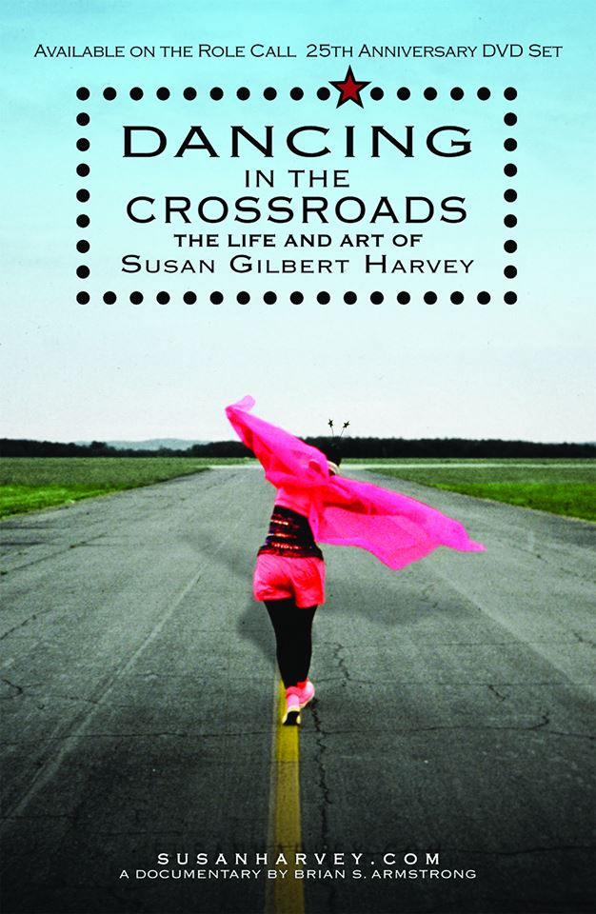

LADIES LUNCHEON – Ladies of St. Peter’s Luncheon
Saturday February 11th at 11:30am in Daniel Hall
Guest speaker Susan Harvey, her talk is titled, Dancing in the Crossroads, a spiritual journey. She will discuss her life pilgrimage since being baptized at St. Peter’s in 1951 at age 14.

Bring a favorite dish to share. Suggestions: quiche, fruit salad, sandwiches, dessert. Perhaps a recipe from Our Best to You, St. Peter’s Cookbook.

WEDNESDAY MEAL Chicken Pot Pie Adults $5 and children $3. Family maximum $20. Food is prepared based on RESERVATIONS please contact the church office by TUESDAY to reserve your meal.

NEWSLETTER DEADLINE – Deadline for the FEBRUARY NEWSLETTER is FRIDAY, 2/03/2017. Submissions should be made to Bryant Steele steelecomm@netzero.net. If you are NOT receiving the newsletter contact the church office to validate contact information.

KEYS Appreciation to those that have called or emailed the church office to acknowledge keys in your possession. If you have keys to any of the church buildings; please call or email the church office.

OUTREACH – Let's help warm the less fortunate of Rome. Please donate new or gently used scarves, gloves, knit caps, rain ponchos, hand warmers, and thick socks. These will be shared with residents of The Salvation Army, The Shelter, and guests of The Community Kitchen. Containers are located in the hallway between Daniel Hall and The Rhodes Wyatt Room. Checks may be made out to St. Peter's and designated January Outreach.

ALL COLLEGE STUDENTS are invited to join the Canterbury Club for Food & Fellowship on Monday evening at 6:00 in the Berry College Admissions Office Living Room. Join us for a light supper (graciously provided by St. Peter's own Peggy Nash & Andye Moss), student led conversation, and prayers for the evening. Bring friends!

COLLEGE STUDENTS are also invited to join Canterbury Club for the Diocese of Atlanta Campus Ministry Retreat February 17-19 at Camp Mikell in Toccoa, Georgia. The theme of the retreat is Toward Wholeness. The entire concept for this retreat has been created and planned by students from Emory University, Georgia Tech, Kennesaw State University and Berry College. The retreat focuses on having real conversations about real life situations we encounter. Our theme is focusing on four different aspects of life – our spiritual, emotional, physical and intellectual sides of life and how Christ affects all aspects in our life. While exploring our faith, we hope to help retreat goers put themselves on a path toward wholeness through Christ. Contact Janice Wright or Lydia Schlitt for registration details.

PRAYING IN COLOR – Mondays at 1:00 meet at 401 East 4th Avenue. Praying in Color based on the book, Praying in Color by Sybil Macbeth. It is a quiet time with a focus of intention, doodling and contemplation. The lectio divina technique will be utilized. You do not need to be artistically inclined & you do not need to show your worke. If you have a sketch pad and markers, please bring them; if not some will be provided. Books may be ordered on Amazon. Contact D’Ann if you are in attending: ddowneywarley@comcast.net
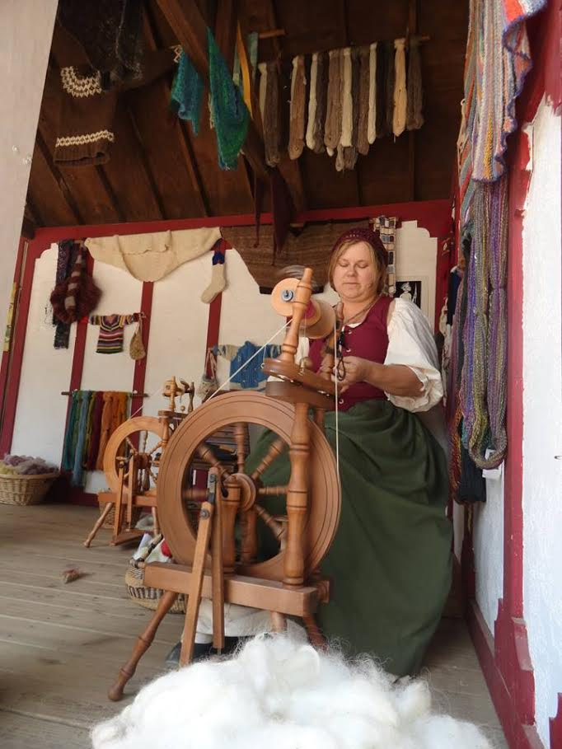

MIKELL FOLK SCHOOL March 3 – 5, 2017.
Registration forms available contact the church office or on line at campmikell.com. Classes available in: Basket Weaving, Felting, Knitting, Spinning, Cooper Enameling, Photography, Stained Glass, Writing, Quilting, Mosaics, Weaving and Woodturning.

Church Office: Phone - 706.291.9111 Fax - 706.232.5007 Email: elizabeth@stpetersrome.org
Office Hours: Monday – Thursday 8am to 4pm and Friday 9am to 12 noon
Website: stpetersrome.org Facebook: St Peter’s Episcopal Church
CHILDREN’S CORNER!
Fourth Sunday after Epiphany
Today in:
Children’s Chapel (pre-K through 3rd grade)- In class, the children explore what how it might feel to return back to a place you love and celebrate that return. They will also learn about the Israelites rebuilding the Temple. God was faithful to His promise to bring His people home and God is faithful to His promises today.

Children’s Sunday School (pre-K through 5th grade) We are on Chapter 19 of the Story, The Return Home. In this chapter, the children explore what how it might feel to return back to a place you love and celebrate that return. They will also learn about the Israelites rebuilding the Temple. God was faithful to His promise to bring His people home and God is faithful to His promises today.

Rite 13- (6th & 7th grades)-This is a 2 year class focusing on recognizing the gifts God has given us, celebrating our creative potential, and learning to interact as a community of faith. Students study scripture, engage in prayer, and enter discussion on a variety of topics which offer them tools for faithful living in our church community and in the wider world.

J2A (Journey to Adulthood)- (8th and 9th grades minimum, older students are welcome) Students study scripture, engage in prayer, and enter discussion in which they learn and practice six basic skills of adulthood: active listening, negotiation, assertion, research & information management, partnership and leadership. There will also be discussions about the upcoming J2A pilgrimage planned for the early summer of 2018. Students who wish to go on pilgrimage must attend Sunday School.

YAC- (Young Adults in Church)- YAC aged students (10th grade and above) meet monthly with their mentor, to discuss topics relevant to Christian living as young adults today.

~~~~~EYC EVENTS ~~~~~
TODAY – Sunday 4-6pm Hiking to House of Dreams!
Snacks provided @ the hike’s end. Meet at the parking lot of Berry Frost Chapel.
Parent pick up & drop off at Berry Frost Chapel.
WEDNESDAY 2/1/2017 6:30-8:15pm- Yelling Bee
With snacks! Parent Drop off & pick up at the church.
If you want dinner, come early & enjoy the Parish Family Dinner $5 per student
EYC is open to 6th-12 graders, and all gap year students!

Children’s Chapel and Nursery/Toddler care are available on the 2nd floor of the Education Building during the 10am service, and Sunday School is available for all children and youth, pre-k through High School grades immediately after service. If your younger children are staying with you in the pew during service, we are delighted to have the whole family joining us in worship. Little ones are always welcome.

For Busy Little Hands in Church: We provide scriptural coloring sheets, crayons, and a children’s guide to the Eucharist, in the back of the church to help children in understanding our scripture readings and our corporate worship.

Parents/guardians of children in 5th grade or younger, please continue to escort your children to and from class, and sign them in and out. This is part of how we keep our little lambs safe.

