ANNOUNCEMENTS
January 15, 2017
“Enter reverently, meditate quietly, worship devoutly, leave gratefully, serve Christ faithfully.”

WELCOME TO ALL OUR VISITORS! If you are interested in knowing more about St. Peter’s, please see an usher or one of the greeters who stand with the clergy after the service.

TODAY AT ST. PETER'S
8:30 am Holy Eucharist Rite I
9:00 am Breakfast
10:00 am Holy Eucharist Rite II (Nursery available)
Children’s Chapel
11:15 am Wired Word, Adult & Youth Formation
4:00 pm EYC – Hidden Figures Matinee

LOOKING AHEAD:
January 16 NO Canterbury Club tonight
January 17 Chair Yoga 11am
January 17 Healing Service 12:15 pm
January 18 Celtic Service, Adult & Children’s Choir, Dinner
January 18 EYC – Photo Scavenger Hunt
January 19 Bible Study 10am – Hebrews

LAY MINISTERS: (8:30) Reader/Prayers/Chalice Bearer—Mark Jester
(10:00) 1st Lesson—Betsy Awsumb; 2nd Lesson—Tom Dasher; Prayers—Bob Berry; Chalice Bearers—Alex Hodges, Annette Morris, Sunny Knauss, Tom Dasher.

CHURCH ALTAR ARRANGEMENTS are given by Jan Routledge and Jason Roberson to the Glory of God and in loving memory of Willie Mae Dixon, her mother and his grandmother.

CHAPEL ALTAR ARRANGEMENTS are given by Cooper, Madge, Asa, Will, and Hank Crawford to the Glory of God and in loving memory of Jerry Norwood Crawford.

SYMPATHY OF THE PARISH is extended to Jack Niedrach and Lee Niedrach on the death of their mother and grandmother, Fern Niedrach on 1/6/2017; and to Clem Trammell on the death of his father, Gene Trammell on 1/12/2017.

INTERCESSORY PRAYER LIST – Rafael Carballo, Beth Hughes, Kathleen Bracken, Bill Fricks, Linda Cummings, Nancy Phillips, Carolyn Yongue, Barbara Wyatt, Jane Swanson, Charlie Rutledge, Mike Alexander, Neil Sanders, Delores Nowell, Wayne Johnston, Bonnie Reeder, Ron Schmidt, Malou Noth, Brandi Edgeworth, Sammy Edgeworth, Deseri Wooten, Sarah Wilbur, Jane Stegall Mosley, Ira Cole, Michael Foster, Pat York, Bill Segars, Len Woodward, Joel Jones Jr., and Carey Kilgore.

To add a name to the PRAYER LIST, call or email the church office. Please note that the prayer list will be refreshed the first Sunday of every month. To renew your requests, please call the church office during the last week of the month. 706.291.9111 or elizabeth@stpetersrome.org

Happy Birthday to those celebrating birthdays (January 15 – January 21) Bee Chidsey, Bess Kelley, Elliot Wilson, Bethany Evans, Haywood Patton, Margaret Olivera, Julie Ouseley, Laura Frederick, Mary McGuffey, Charles Hight, Mike Barron, Rebecca Roberts.

WIRED WORD meets in the Rhodes-Wyatt room immediately following the 10:00 a.m. Eucharist. Each week we take an item from the news or current events and provide an opportunity to reflect on how our faith responds to or interacts with the concern through a mixture of scriptures, big questions, and discussion. “Wired Word” encourages participants to consider how following Jesus puts them in touch with the wider world.

ADULT FORUM Join us in Daniel Hall immediately after the 10:00 a.m. Eucharist for our continuing study of The Story. This week we will discuss The Kingdom’s Fall (Chapter 17). Please read Chapter 18 for January 22.

PRAYING IN COLOR - Monday, January 23 at 1:30 meet at home of D’Ann Downey; 401 East 4th Avenue. Praying in Color based on the book, Praying in Color by Sybil Macbeth. It is a quiet time with a focus of intention, doodling and contemplation. The lectio divina technique will be utilized. You do not need to be artistically inclined & you do not need to show your worke. If you have a sketch pad and markers, please bring them; if not some will be provided. Books may be ordered on Amazon. Contact D’Ann if you are in attending: ddowneywarley@comcast.net
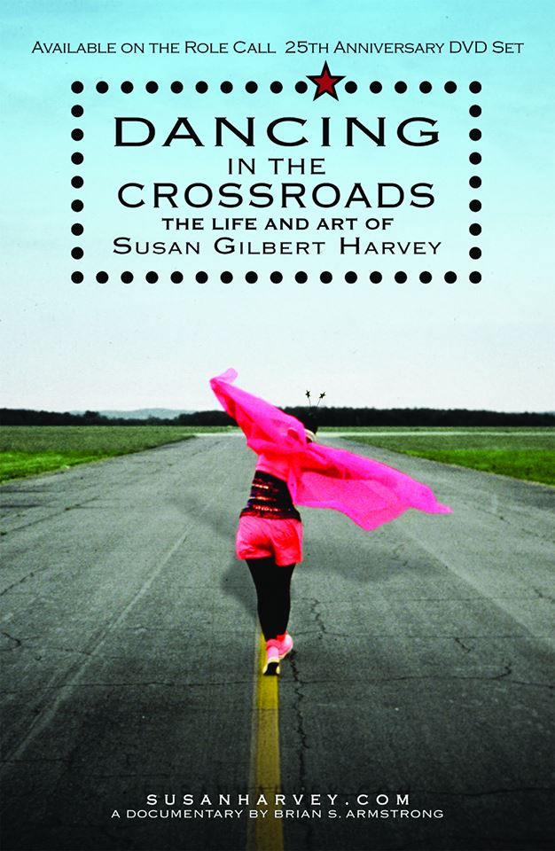

LADIES LUNCHEON – Ladies of St. Peter’s Luncheon
Saturday February 11th at 11:30am in Daniel Hall
Guest speaker Susan Harvey, her talk is titled, Dancing in the Crossroads, a spiritual journey. She will discuss her life pilgrimage since being baptized at St. Peter’s in 1951 at age 14.

Bring a favorite dish to share. Suggestions: quiche, fruit salad, sandwiches, dessert. Perhaps a recipe from Our Best to You, St. Peter’s Cookbook.

WEDNESDAY MEAL Turkey Rosemary Meatloaf, Mashed Potatoes, Veggies Adults $5 and children $3. Family maximum $20. Food is prepared based on RESERVATIONS please call the office 706.291.9111 by TUESDAY to reserve your meal.

CANTERBURY CLUB will NOT meet this Monday night 1/16/2017 as Berry College observes the MLK holiday. Meetings resume on Monday, January 23, at 6:00 p.m. in the Berry College Admissions Office Living Room. Save the date for Canterbury Club service in the Community Kitchen on Thursday morning, January 26. Watch your email box for details.

COMMUNITY SOUP KITCHEN
Volunteer for St. Peter’s day to staff the community kitchen on January 20, 2017 either 8:30am or 10:15am shift.
Contact Andye Moss agm614@aol.com.

FLOWER DATE Contact Laura Frederick if you would like to place flowers in the Chapel on February 26, 2017 in honor or memory of someone.

OUTREACH – January 2017 Let's help warm the less fortunate of Rome. Please donate new or gently used scarves, gloves, knit caps, rain ponchos, hand warmers, and thick socks. These will be shared with residents of The Salvation Army, The Shelter, and guests of The Community Kitchen. Containers are located in the hallway between Daniel Hall and The Rhodes Wyatt Room. Checks may be made out to St. Peter's and designated January Outreach.

KEYS If you have a set of keys to any of the church properties please call 706.291.9111 OR email elizabeth@stpetersrome.org. We are compiling a complete list of all individuals and the keys they have. THANK YOU

CHURCH UPDATE – Has your address, phone number or email changed? Contact the church office with any changes to ensure you remain plugged into the happenings at St. Peter’s.

2016 GIVING STATEMENTS have been mailed. Please review your statement and notify the church office by 2/1/2017 if there are any discrepancies (706.291.9111 or elizabeth@stpetersrome.org)

OFFICE CLOSED – Tomorrow, Monday 1/16/2017 in observance of Martin Luther King.

CHILDREN’S CORNER!
Second Sunday after Epiphany
Today in:
Children’s Chapel (pre-K through 3rd grade)- In class, they will learn about how the Divided Kingdom fell. The kings didn’t follow God’s instructions, the people worshipped false gods, and then an enemy army came to defeat the kings and capture all the people. But God still did not abandon them. God promises that one day, God’s people will again be safe and free, and that a new King, a good King would rule.

Children’s Sunday School (pre-K through 5th grade) We are on Chapter 17 of the Story, in which children will learn about how about how the Divided Kingdom fell. The kings didn’t follow God’s instructions, the people worshipped false gods, and then an enemy army came to defeat the kings and capture all the people. But God still did not abandon them. God promises that one day, God’s people will again be safe and free, and that a new King, a good King would rule.

Rite 13- (6th & 7th grades)-This is a 2 year class focusing on recognizing the gifts God has given us, celebrating our creative potential, and learning to interact as a community of faith. Students study scripture, engage in prayer, and enter discussion on a variety of topics which offer them tools for faithful living in our church community and in the wider world.

J2A (Journey to Adulthood)- (8th and 9th grades minimum, older students are welcome) Students study scripture, engage in prayer, and enter discussion in which they learn and practice six basic skills of adulthood: active listening, negotiation, assertion, research & information management, partnership and leadership. There will also be discussions about the upcoming J2A pilgrimage planned for the early summer of 2018. Students who wish to go on pilgrimage must attend Sunday School.

YAC- (Young Adults in Church)- YAC aged students (10th grade and above) meet monthly with their mentor, to discuss topics relevant to Christian living as young adults today.
~~~~~EYC EVENTS ~~~~~
Wednesday 1/18/2017 6:30-8:15pm- Photo Scavenger Hunt at the church (outside if it is warm); don’t worry it will be a challenge, cupcake and candy treats so no one faints from hunger. Come early if you want dinner and enjoy the Parish Family dinner $5 for students.
EYC is open to 6th-12 graders, and all gap year students!

Children’s Chapel and Nursery/Toddler care are available on the 2nd floor of the Education Building during the 10am service, and Sunday School is available for all children and youth, pre-k through High School grades immediately after service. If your younger children are staying with you in the pew during service, we are delighted to have the whole family joining us in worship. Little ones are always welcome.

For Busy Little Hands in Church: We provide scriptural coloring sheets, crayons, and a children’s guide to the Eucharist, in the back of the church to help children in understanding our scripture readings and our corporate worship.

Parents/guardians of children in 5th grade or younger, please continue to escort your children to and from class, and sign them in and out. This is part of how we keep our little lambs safe.

