ANNOUNCEMENTS
January 14, 2018
“Enter reverently, meditate quietly, worship devoutly, leave gratefully, serve Christ faithfully.”

WELCOME TO ALL OUR VISITORS! If you are interested in knowing more about St. Peter’s, please see an usher or one of the greeters who stand with the clergy after the service.

TODAY AT ST. PETER'S
8:30 am Holy Eucharist Rite I
9:00 am Breakfast
10:00 am Holy Eucharist Rite II (Nursery available)
Children’s Chapel
11:15 am Formation for Adults, Youth & Children
1:00 pm Eucharist in Spanish, Chapel

LOOKING AHEAD:
Monday/January 15 OFFICE CLOSED
Tuesday/ January 16 Chair Yoga 11 am
Healing Service 12:15 pm
Canterbury Club 5:30 pm Berry
Wednesday/January 17 Celtic Service 5:30 pm
Parish Dinner 5:45 pm
Episcopal 101 6:30 pm
Thursday/January 18 Bible Study 10 am
Centering Prayer 6:30 pm
Friday/January 19 Restoration Rome 9 am to noon

LAY MINISTERS: (8:30) Reader/Prayers/Chalice Bearer – Rachel Jones;
(10:00) 1st Lesson –Randa Mixon; 2nd Lesson – Randy Muller; Prayers – Brian Hampton; Chalice Bearers –Annette Morris, Bryan Johnson, Beth Hughes, Sunny Knauss.

ALTAR CANDLES are given by the Norma Littlejohn to the Glory of God and in memory of departed family members.

ALTAR ARRANGEMENTS are given by Patti and Mike Barron to the Glory of God and in thanksgiving and in memory of Cliff Rogers.

CHAPEL ARRANGEMENTS are given by Tricia Richards to the Glory of God and in memory of departed loved ones.

INTERCESSORY PRAYER LIST Charlie Rutledge, Mike Alexander, Neil Sanders, Fran Bagley, Jack Edgens, June Dellis, Alicia Segars, Jamie Hughes, Mildred Edgeworth, Ivy Sirmans, Regan Hice, Suzanne Black, John Flanigen III, Joe McNair, Greg Bauer, Susan Harvey, Bryant Steele and those who provide them care.

To add a name to the PRAYER LIST or MILITARY LIST, contact the church office. The prayer list will be refreshed the 1st Sunday of every month.

SYMPATHY OF THE PARISH extended to Rachel Rivera on the death of her grandfather, Charles Wyrick who died on January 6, 2018

Happy Birthday to those celebrating birthdays (January 14 – January 20)
Simon Wilson, Bee Chidsey, Bess Kelley, Elliot Wilson, Dan Mozley, Bethany Evans, Haywood Patton, Margaret Olivera, Julie Ouseley, Laura Frederick, Mary McGuffey, Charles Hight.

BAPTISM – Last Sunday we welcomed into the household of God:
Harris West McElrath, son of Ben and Sarah McElrath.

ADULT FORUM in January we explore topics that will serve to recharge & re-energize.
- January 14 – Living Compass, Discussion of Strengths & Weaknesses of the Congregation of St. Peter’s.
- January 21 & 28 – Steve Safigan, former founder/CEO of Universal Tax, currently a certified Brene Brown facilitator will lead a discussion on finding courage in our daily lives using the book Daring Greatly.

EPISCOPAL 101 - Are you considering Confirmation or joining the Episcopal Church? Perhaps you are interested in learning more about our tradition? An inquirers class for adults will meet Wednesday nights.
Jan. 10 – March 21st at 6:30 p.m.
It’s NOT too late to Join the Class, see you Wednesday.

TIME & TALENT – Your 2018 Time and Talent form is in the mail. Looking for an activity, program or area of the church where YOU can get involved and make a difference? Regardless of skill set there is a place for YOU. Please review the areas of opportunity to serve in your parish, then return a completed form for each parishioner by FEBRUARY 2nd. Mail, fax or email to the church office.

WEDNESDAY PARISH DINNER – 5:45 pm
Adults $5, Children $3 family maximum $20.
Speak Cheesy, your choice 1) Three Cheese – cheddar, gruyere & mozzarella 2) The ABC – apple, bacon, cranberry and cheddar.
Call the office by NOON on Tuesday with your reservation or to make changes to your standing reservation.

CANTERBURY CLUB - Meetings resume Tuesdays 5:30 pm in the Berry College Admissions Living Room. College students, faculty, staff, alums and friends are welcome to join us! Not Berry Student, but want to participate? No problem! Text Rebecca for directions or a ride.

If you feel called to provide a meal for our Tuesday evening meetings, please call Rebecca Segrest 706.331.6363.

Mark Your Calendars!
January 15th join with Canterbury for a Day of Service
January 20th Civil Rights Museum in Birmingham
February 11th visit to the Church of the Common Ground in Atlanta.

LIVING COMPASS – “Thy Kingdom Come”
is a phrase we often say but may not pause to really consider the power of the words. What do we mean by “Thy Kingdom Come?” What can we do to increase our awareness of the divine within? This is the question we will explore in this 2-week class. We will approach this question directly and indirectly. The indirect method will draw on our subconscious, spontaneous processes. This will be a fun, meaningful and interactive group.
Wednesday - January 31st & February 7th at 6:30 p.m. Willingham House
Monday - February 5th & February 12th at 1 p.m. at 401 East 4th Avenue.

It would be helpful to know ahead of time if you plan to attend so I will have enough supplies on hand.
Please contact me at ddowneywarley@comcast.net or 706 266-3444.

NEW DIRECTORIES ARE IN – If you had your picture taken for the St. Peter’s directory your complimentary directory is in the office. Please stop by and pick your copy up today.

FEBRUARY 11th LUNCHEON served by our Youth. Auction will be held to raise funds for Pilgrimage to Italy. Mark your calendars, come and enjoy spaghetti, green salad, garlic toast and homemade tiramisu. NO CHARGE for the lunch.
CHILDREN’S CORNER!

Second Sunday after Epiphany

Nursery/Toddler care is available and is located on the 2nd floor of the Education Building for the 10am service, beginning at 9:45am.

Children’s Chapel is available for children ages pre-k through 3rd grade during the 10am worship service on the 2nd floor of the Education Building.
If your younger children are staying with you in the pew during service, we are delighted to have the whole family joining us in worship.

Little ones are always welcome.

For Busy Little Hands in Church: We provide scriptural coloring sheets, crayons, and a children’s guide to the Eucharist, in the back of the church to help children in understanding our scripture readings and our corporate worship.
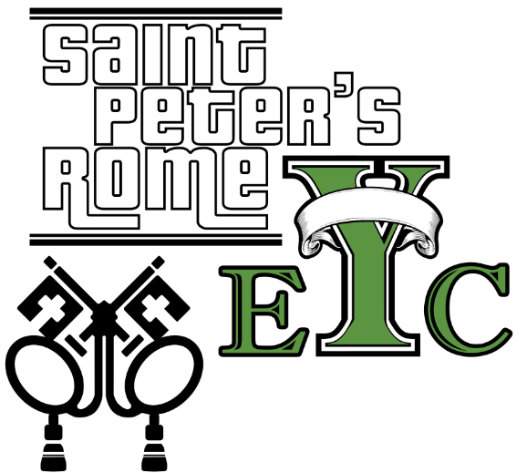
EYC on Wednesday
Board Games with CASH prizes
NEW TIME: 7:15pm
EYC is open to all students grades 6 to 12.
Friends are Welcome!

ON WEDNESDAY St. Peter’s is where YOU want to be!

2017 GIVING STATEMENTS – Your giving statements have been mailed. Please REVIEW them carefully and contact the church office
by January 31st with any discrepancies.

Church Office: Phone - 706.291.9111 Fax - 706.232.5007 Email: elizabeth@stpetersrome.org
Mail Address: 101 East Fourth AVENUE, Rome GA 30161
Office Hours: Monday – Thursday 8am to 4pm and Friday 9am to 12 noon
St Peter’s Episcopal Church/St Peter’s Sunday School/St. Peter’s Rome EYC
St. Peter’s Junior Choir
www.stpetersrome.org

