ST. PETER’S Vacation Bible School
June 5th-9th, 2017
9am to noon

Ages 4yrs to 5th grade
Nursery provided

Get ready for Rome:
Paul and the Underground Church!
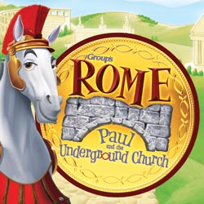
We’ll follow along with St. Paul as he does God’s work to strengthen God’s people and put in place the foundation of the church we know today!

Contact church office for VBS Registration Form

